**Project Management and Execution**

I have successfully led and managed multiple interdisciplinary projects across academia, research, and industry collaborations with a focus on innovation, scalability, and impact. My project handling expertise spans from conceptualisation to execution, encompassing proposal writing, resource mobilisation, team coordination, technical supervision, progress monitoring, and final reporting. Key highlights include:

* **Strategic Planning:** Developed comprehensive project plans aligned with organisational goals, including clearly defined objectives, milestones, and deliverables.
* **Cross-Functional Leadership:** Supervised diverse teams comprising faculty, research scholars, developers, and external stakeholders to ensure cohesive progress and timely delivery.
* **Funding and Collaboration:** Secured competitive research grants and facilitated collaborations with government bodies, academic institutions, and industry partners.
* **Risk Management:** Identified potential risks and implemented mitigation strategies to ensure smooth project execution under defined budgets and timelines.
* **Technical Oversight:** Provided subject matter expertise in domains such as Artificial Intelligence, IoT, Explainable AI, and Federated Learning to drive innovation and ensure technical robustness.
* **Monitoring and Evaluation:** Utilized standard project management tools for tracking progress, evaluating performance metrics, and maintaining documentation as per funding agency guidelines.
* **Reporting and Dissemination:** Prepared detailed progress and final reports; presented outcomes at national and international forums; and published results in reputed journals and conferences.

Each project undertaken reflects a commitment to academic excellence, technological advancement, and societal impact.

Contents

Personalised Treatment Planning in Healthcare 3

Algorithmic Fairness in Hiring and Lending 6

Healthcare Treatment Efficacy and Patient Outcomes 9

Legal Liability and Accident Analysis 13

Computational Advertising and Marketing Lift 16

Cognitive Behavioural Therapy (CBT) 19

Supply-Chain Risk Management 22

Network Optimisation in Humanitarian Logistics 25

Educational Policy Evaluation 28

Public Health Program Evaluation 32

Finance: Credit Assessment and Risk Management 35

Marketing: Promotion Lift Analysis 38

Manufacturing: Fault Detection and Root Cause Analysis 41

Cybersecurity: Breach Attribution 44

Retail: Demand Forecasting and Inventory Management 48

Agriculture: Crop Management 51

Disaster management 55

Climate Science: Human Impact Analysis 58

Smart Urban Planning: Sustainability Analytics 61

Fraud Detection: Transaction Analysis 64

Customer Retention: Churn Prediction 67

Public Policy Analysis: Program Evaluation 70

Reduce Tobacco Consumption 73

Effective performance and right wage utilization 77

# Personalised Treatment Planning in Healthcare

**Projects Overview**

Personalised treatment planning in healthcare refers to the development of medical strategies that are specifically tailored to an individual’s unique characteristics, including their genetic profile, lifestyle, environment, and medical history. This patient-centric approach aims to enhance the effectiveness of treatments while reducing the risk of adverse effects. By promoting proactive prevention, active patient engagement, and collaborative decision-making between healthcare providers and patients, personalised treatment planning contributes significantly to improved clinical outcomes and overall well-being.

**Step-by-Step Implementation Process**

Implementing Personalised Treatment Planning in Healthcare using Explainable Artificial Intelligence (XAI) with Counterfactual Explanations in Federated Learning (FL) frameworks, and incorporating Causal Directed Acyclic Graphs (DAGs), can be broken down into a general step-by-step process as follows:

**Step 1: Federated Data Collection across Healthcare Institutions**

* **Objective**: Gather patient data (e.g., EHRs, genomics, lifestyle, imaging) from multiple hospitals without moving the data to a central server.
* **Approach**: Use **Federated Learning (FL)** to train models collaboratively across decentralized nodes (hospitals) while ensuring data privacy and compliance with regulations (e.g., HIPAA, GDPR).

**Step 2: Model Training Using Federated Learning**

* **Objective**: Develop a global predictive model for disease risk, treatment outcomes, or drug response.
* **Approach**:
  + Local models are trained at each node using local patient data.
  + Model updates (not raw data) are sent to a central server for aggregation.
  + This continues iteratively until convergence.

**Step 3: Incorporation of Causal DAGs for Personalised Insights**

* **Objective**: Understand cause-effect relationships between variables (e.g., how a genetic factor causes a side effect to a drug).
* **Approach**:
  + Construct **Causal DAGs** using domain knowledge and statistical methods.
  + Use DAGs to identify confounders, mediators, and effect modifiers for treatments.
  + This causal reasoning enables more accurate and meaningful personalisation.

**Step 4: Explainable AI for Transparent Decision-Making**

* **Objective**: Make AI predictions understandable to clinicians and patients.
* **Approach**:
  + Apply **Explainable AI (XAI)** methods (e.g., SHAP, LIME) to interpret model decisions.
  + Link explanations with causal pathways from DAGs to strengthen trust in decisions.

**Step 5: Generation of Counterfactual Explanations**

* **Objective**: Show “what-if” scenarios to guide personalised treatment.
* **Approach**:
  + For example: "If the patient reduced their BMI by 5 units, the predicted risk of heart disease would decrease by 20%."
  + Counterfactuals derived from the model and causal graphs help clinicians explore alternative interventions or treatments tailored to the individual.

**Step 6: Personalised Treatment Recommendation**

* **Objective**: Provide actionable and personalised treatment strategies.
* **Approach**:
  + Use predictive and counterfactual insights to suggest interventions (e.g., choosing Drug A over Drug B).
  + Recommendations are shared with the patient and physician, enabling **shared decision-making** based on both scientific evidence and personal preferences.

**Step 7: Continuous Feedback and Model Refinement**

* **Objective**: Adapt and improve the model based on new outcomes and patient feedback.
* **Approach**:
  + Integrate post-treatment data into the FL process for continuous learning.
  + Update causal models and explanations as more real-world evidence becomes available.

**Benefits of This Framework**

* **Privacy-preserving** (via FL)
* **Clinically interpretable** (via XAI and causal DAGs)
* **Patient-specific** (via counterfactuals and personalised data)
* **Scientifically grounded** (via causal inference)
* **Adaptive** (via continuous learning and feedback)

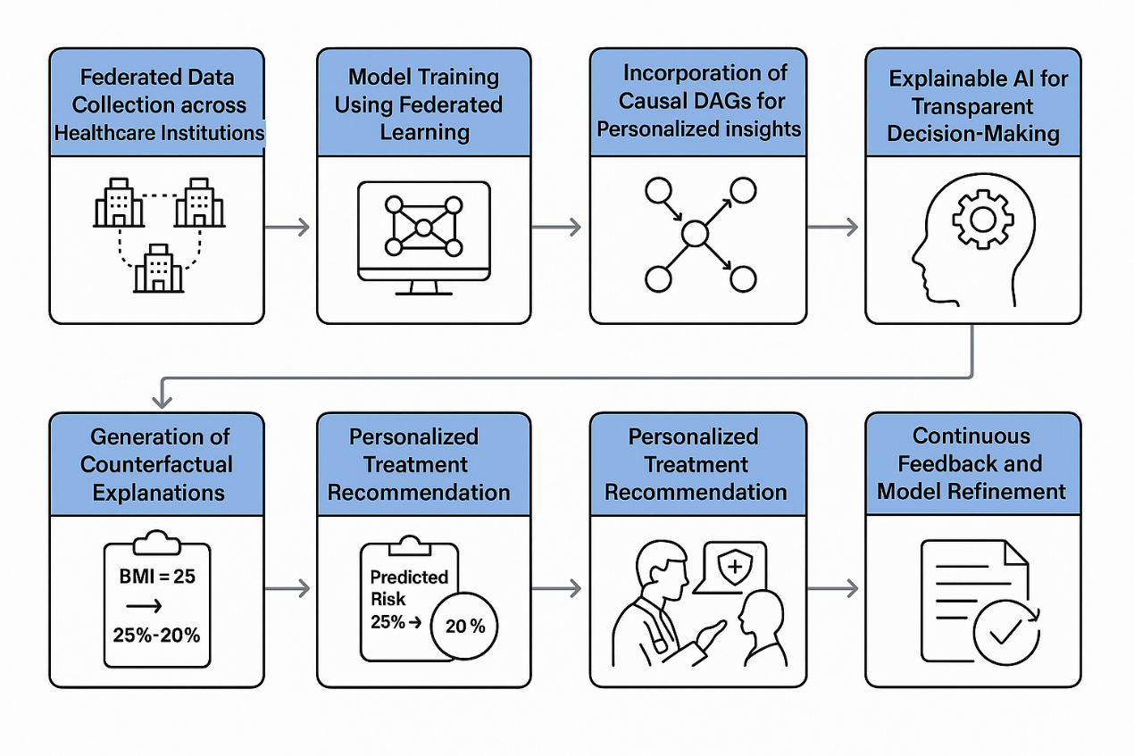

# Algorithmic Fairness in Hiring and Lending

**Projects Overview**

Algorithmic fairness plays a crucial role in ensuring unbiased and objective decision-making, particularly in domains such as human resources and financial services. In hiring processes, algorithms can be designed to identify and evaluate relevant skills and qualifications that align with job requirements, thereby promoting merit-based selection and reducing human bias. Similarly, in lending scenarios, fair algorithms support equitable loan approval decisions by assessing applicants based on consistent, transparent criteria. Applications of such fairness-focused algorithms extend to areas like employee recruitment, credit risk assessment, and even player selection in competitive environments.

**Step-by-Step Implementation Process**

A step-by-step explanation of how Algorithmic Fairness can be implemented in hiring and lending decisions using Explainable Artificial Intelligence (XAI) with Counterfactual Explanations in Federated Learning (FL) Frameworks, leveraging Causal Directed Acyclic Graphs (DAGs):

**Step 1: Data Collection Across Federated Nodes**

* **Context**: Multiple institutions (e.g., banks, companies) retain local user data (candidates or applicants).
* **Action**: Using the **Federated Learning (FL)** paradigm, models are trained locally without transferring sensitive data, preserving privacy.
* **Goal**: Ensure diverse and decentralized data sources contribute to model training.

**Step 2: Identify Sensitive and Non-Sensitive Attributes**

* **Context**: Attributes such as gender, race, or socioeconomic background must be identified as **protected variables**.
* **Action**: Tag variables as either:
  + **Sensitive** (must not influence outcomes unfairly)
  + **Non-sensitive** (skills, qualifications, income, etc.)
* **Goal**: Ensure the model focuses on fair, job-relevant or finance-relevant features.

**Step 3: Construct Causal DAGs**

* **Context**: A **Causal Directed Acyclic Graph (DAG)** represents cause-effect relationships among variables.
* **Action**: Model designers build DAGs to visualize and quantify the direct and indirect effects of variables on the outcome (e.g., hiring decision or loan approval).
* **Goal**: Understand if any sensitive variables causally influence outcomes, even indirectly.

**Step 4: Train FL Model with Fairness Constraints**

* **Context**: Use the FL model to learn patterns across decentralized data.
* **Action**: Integrate fairness-aware loss functions or regularization terms that penalize bias (e.g., Equalized Odds, Demographic Parity).
* **Goal**: Achieve fairness during model training without compromising accuracy.

**Step 5: Generate XAI-Based Explanations**

* **Context**: Post-training, the model must be explainable to users and regulators.
* **Action**: Apply **SHAP (SHapley Additive Explanations)** or **LIME** to highlight how each input feature contributed to the decision.
* **Goal**: Enhance transparency for decisions in hiring and lending.

**Step 6: Apply Counterfactual Explanations**

* **Context**: To answer "What minimal changes would have led to a different decision?"
* **Action**:
  + Generate counterfactuals that propose realistic feature modifications.
  + Example: "If the candidate had 2 more years of experience, they would have been shortlisted."
* **Goal**: Provide actionable feedback to users and test fairness — ensure that changing sensitive attributes alone doesn’t flip outcomes.

**Step 7: Validate Fairness with Causal Interventions**

* **Context**: Use the causal DAG to simulate interventions (e.g., changing a sensitive attribute).
* **Action**:
  + Check for counterfactual fairness by intervening on protected attributes.
  + Ensure outcome remains unchanged if only sensitive variables are modified.
* **Goal**: Prove that the model’s predictions are not causally dependent on unfair factors.

**Step 8: Continuous Auditing and Model Updates**

* **Context**: Fairness is dynamic and must be maintained over time.
* **Action**:
  + Periodically retrain models with updated data.
  + Conduct fairness audits using causal and counterfactual analysis.
* **Goal**: Sustain long-term algorithmic fairness and trustworthiness.

**Summary**

This approach integrates privacy-preserving federated learning with robust explainability and fairness auditing. By combining **XAI**, **counterfactuals**, and **causal DAGs**, hiring and lending decisions become transparent, justifiable, and resistant to bias, ensuring ethical AI deployment in high-stakes environments.

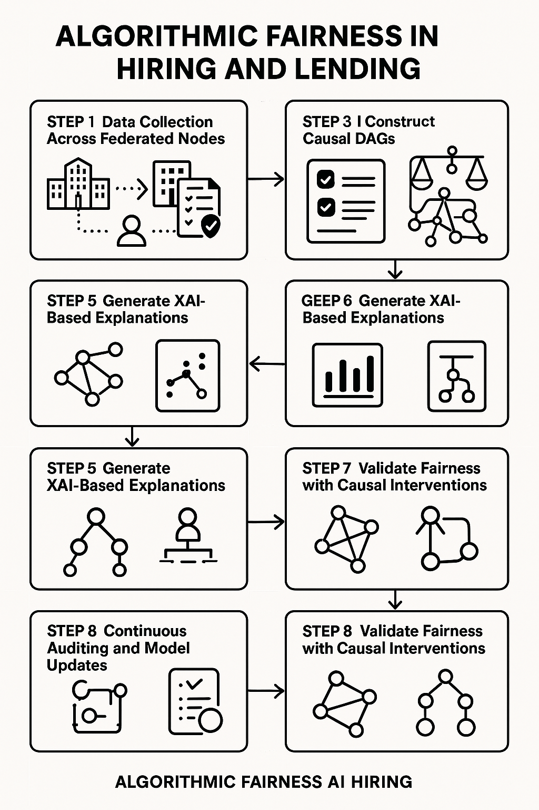

# Healthcare Treatment Efficacy and Patient Outcomes

**Projects Overview**

Improving patient outcomes is a critical objective, involving a comprehensive approach that includes enhancing overall health, promoting recovery, and preventing adverse events. Achieving these outcomes requires effective hospital administration, data-driven decision-making, and active patient engagement, all of which play vital roles in optimizing healthcare delivery and ensuring better patient care.

**Step-by-Step Implementation Process**

The implementation of improving patient outcomes using Explainable Artificial Intelligence (XAI) with counterfactual explanations in Federated Learning (FL) frameworks, incorporating Causal Directed Acyclic Graphs (DAGs), can be achieved through a step-by-step process. Here’s how this can be implemented:

1. **Data Collection and Preprocessing:**
   * **Patient Data Aggregation:** Gather data from multiple healthcare institutions, ensuring that patient data remains secure and compliant with privacy standards (e.g., HIPAA). This data includes patient demographics, medical history, treatment details, and outcomes.
   * **Preprocessing:** Clean and preprocess the data to remove any inconsistencies or missing values. Normalize data if necessary for better performance.
2. **Federated Learning (FL) Setup:**
   * **FL Framework Initialization:** Set up a federated learning framework where multiple institutions (hospitals or clinics) train machine learning models collaboratively without sharing raw data.
   * **Local Model Training:** Each participating institution trains a local model using its own data. The local model updates are aggregated (using techniques like Federated Averaging) and sent to a central server for the global model update.
3. **Model Training:**
   * **Machine Learning Model Selection:** Choose appropriate machine learning models (e.g., decision trees, neural networks, etc.) to predict patient outcomes. These models are trained across multiple federated nodes to understand patient health and treatment efficacy.
   * **Global Model Update:** The central server aggregates the updates from all participating institutions to form a global model, which improves the predictive accuracy while maintaining data privacy.
4. **Integration of Causal Directed Acyclic Graphs (DAGs):**
   * **Graph Construction:** Develop a Causal Directed Acyclic Graph (DAG) to model the relationships between various factors influencing patient outcomes. For example, nodes could represent patient demographics, clinical factors, treatments, and outcomes, with edges indicating causal relationships.
   * **Causal Inference:** Use the DAG to identify key variables that influence treatment efficacy and patient outcomes. This allows the model to better understand the direct and indirect relationships between variables.
   * **Intervention Simulation:** The DAG can be used to simulate potential interventions and their expected impact on patient outcomes, providing insight into how certain treatments or actions might improve recovery.
5. **Explainable AI (XAI) Techniques:**
   * **Model Explanation:** Apply explainable AI techniques, such as LIME (Local Interpretable Model-agnostic Explanations) or SHAP (SHapley Additive exPlanations), to provide interpretability for the machine learning models. These techniques help clinicians understand why a model made a particular prediction about a patient's outcome.
   * **Causal Explanations:** Use counterfactual reasoning to explain patient outcomes. For example, a counterfactual explanation might suggest, “If the patient had received Treatment A instead of Treatment B, their likelihood of recovery would have increased by X%.”
6. **Counterfactual Explanations:**
   * **Generate Counterfactuals:** Based on the patient’s data and the trained model, generate counterfactual scenarios. These are hypothetical “what-if” situations that help clinicians understand how different treatments or actions could have changed the outcome.
   * **Impact on Decision Making:** Counterfactual explanations can help healthcare providers make more informed decisions by showing them the potential consequences of different treatment options. This helps in personalized treatment planning, where the model suggests the most effective interventions for individual patients.
7. **Model Evaluation and Refinement:**
   * **Performance Evaluation:** Evaluate the model’s performance based on its ability to predict patient outcomes accurately. Use metrics like accuracy, precision, recall, and F1-score to assess prediction quality.
   * **Continuous Learning:** Federated Learning allows the model to continue learning over time as new data is made available from different institutions. This continual improvement can lead to more accurate predictions and better patient outcomes.
   * **Monitoring and Feedback:** Implement a feedback loop where healthcare providers can provide feedback on the counterfactual explanations and model predictions. This feedback helps refine the model for future predictions.
8. **Implementation and Deployment:**
   * **Clinical Decision Support System (CDSS):** Deploy the model within a clinical decision support system (CDSS) where healthcare professionals can access predictions and counterfactual explanations in real-time, aiding them in making better-informed decisions for patient treatment.
   * **Patient Monitoring and Outcome Prediction:** Implement real-time monitoring of patients using the model’s predictions, guiding healthcare providers to detect potential adverse events early, leading to proactive care and improved recovery chances.

**Benefits of This Approach:**

* **Privacy Preservation:** Using FL ensures that patient data remains private and only model updates are shared across institutions, reducing the risk of data breaches.
* **Explainability:** XAI techniques ensure that healthcare professionals can trust the model’s decisions, providing clarity and reasoning behind predictions and counterfactual outcomes.
* **Improved Decision Making:** By providing counterfactual explanations, healthcare providers gain actionable insights into how different interventions might impact patient outcomes, leading to more personalized and effective treatments.
* **Continuous Improvement:** The federated framework allows for continuous learning and model refinement, keeping the model up-to-date with new patient data and improving its predictive capabilities over time.

This process integrates cutting-edge technologies to enhance healthcare decision-making and improve patient outcomes while ensuring data privacy, interpretability, and continuous model improvement.

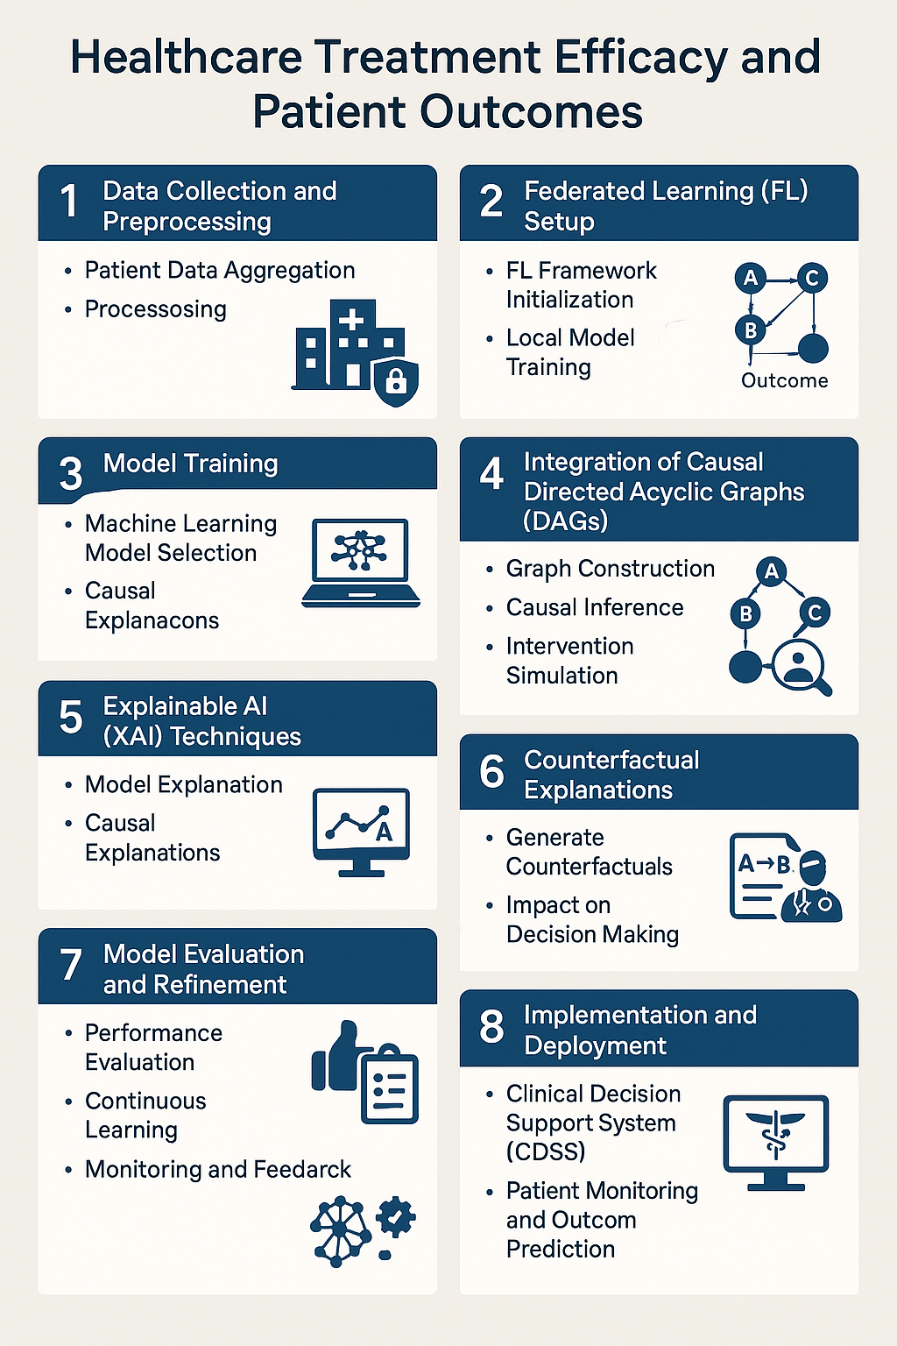

# Legal Liability and Accident Analysis

**Projects Overview**

Legal liability in the context of accidents refers to the determination of responsibility for compensating victims for harm resulting from an accident. It involves assessing when an individual or entity is legally obligated to provide compensation based on the circumstances of the incident. Accident analysis, on the other hand, focuses on investigating the causes and contributing factors of accidents to identify their root causes. This analysis is essential for implementing preventive measures and ensuring compliance with relevant legal and regulatory requirements. Legal liability is typically established through various legal doctrines, such as negligence, strict liability, and product liability, each applicable depending on the specifics of the accident and its context.

**Step-by-Step Implementation Process**

To implement Legal Liability and Accident Analysis using Explainable Artificial Intelligence (XAI), with Counterfactual Explanations within Federated Learning (FL) frameworks and leveraging Causal Directed Acyclic Graphs (DAGs), we can break down the process into the following general step-by-step approach:

**1. Data Collection and Preparation**

* **Step 1.1: Data Gathering**

Collect accident-related data from various sources such as accident reports, sensor data, eyewitness accounts, and historical accident records. This data could include details such as accident location, involved parties, environmental conditions, vehicle specifications, and human factors.

* **Step 1.2: Data Preprocessing**

Clean and preprocess the data to ensure it is usable. This involves handling missing values, normalizing numerical data, encoding categorical data, and formatting the data for use in machine learning models.

**2. Setting Up the Federated Learning (FL) Framework**

* **Step 2.1: Federated Data Distribution**

Distribute the collected data across different nodes (e.g., hospitals, insurance firms, law enforcement agencies) in a federated setup. This ensures that sensitive data does not need to be shared directly between entities, preserving privacy.

* **Step 2.2: Model Training via Federated Learning**

Train machine learning models locally at each node on the federated data. The models will learn from the data in a decentralized manner. Aggregated learning allows models to update shared parameters without exchanging raw data, maintaining privacy and data security.

**3. Integration of Causal Directed Acyclic Graphs (DAGs)**

* **Step 3.1: Building the Causal DAG**

Construct a **causal DAG** to represent the relationships between different variables involved in accidents (e.g., road conditions, vehicle speed, driver behavior, weather conditions, and traffic patterns). A DAG helps to capture the causal relationships and dependencies between these factors, which are essential for understanding the root causes of accidents.

* **Step 3.2: Causal Inference for Legal Liability**

Use the DAG to infer causality in accident scenarios. This will allow the system to determine which factors (e.g., negligence, malfunctioning parts) contributed most to the accident, which can help in assigning legal liability. The DAG enables the analysis of how various factors (e.g., driver actions, vehicle defects, weather) affect accident outcomes, which can inform compensation and legal responsibility.

**4. Applying Explainable AI (XAI) Techniques**

* **Step 4.1: Model Interpretability with XAI**

Apply XAI methods, such as **LIME** (Local Interpretable Model-agnostic Explanations) or **SHAP** (Shapley Additive Explanations), to explain how the machine learning model makes predictions regarding accident causes, legal liability, or potential consequences. This helps legal professionals understand which features or factors were most influential in determining the outcome, making the process more transparent and interpretable.

* **Step 4.2: Counterfactual Explanations**

Generate **counterfactual explanations**, which provide answers to "What would have happened if…?" This allows users (e.g., accident investigators, legal professionals) to ask questions such as, "What would have been the outcome if the driver had braked earlier?" or "How would the accident have changed if the road conditions were better?" Counterfactuals help in understanding the effects of different actions or conditions on the accident outcome.

**5. Model Deployment and Decision Making**

* **Step 5.1: Legal Liability Analysis**

Once the model is trained and interpretable, it can be used to determine legal liability in accident cases. By analyzing the causal factors in the DAG, along with the accident's predicted outcome, the model can recommend which party (driver, manufacturer, road authority, etc.) may bear legal responsibility.

* **Step 5.2: Integrating Legal Frameworks**

The system must be aligned with legal frameworks such as negligence, strict liability, or product liability. The model can be calibrated to provide recommendations based on these frameworks, helping legal professionals make informed decisions.

**6. Iterative Learning and Updates in the FL System**

* **Step 6.1: Continuous Learning**

As new accident data comes in, the federated system can update the model continuously without compromising data privacy. The model can learn from new patterns, improving its predictions over time.

* **Step 6.2: Legal and Ethical Compliance**

Regular updates ensure that the model adapts to new legal rulings, accident prevention strategies, and evolving regulations. This helps maintain ethical standards while ensuring compliance with changing laws and regulations related to accident liability.

**7. Final Interpretation and Legal Support**

* **Step 7.1: Providing Transparent Reports**

The final model outputs can be presented as interpretable reports that explain the accident analysis and legal liability in a clear, understandable way, helping legal professionals and insurance agencies make decisions.

* **Step 7.2: Decision Support for Liability Assignment**

The system supports decision-makers by providing evidence-based insights into who should be held accountable for the accident and why, backed by the causal analysis, accident data, and legal framework.

**Summary:**

This step-by-step process integrates **Federated Learning** for data privacy, **Causal DAGs** for understanding accident causes, **XAI** for model transparency, and **counterfactual explanations** for providing actionable insights. By combining these technologies, we can effectively determine legal liability and prevent future accidents while ensuring ethical and legal compliance in the decision-making process.

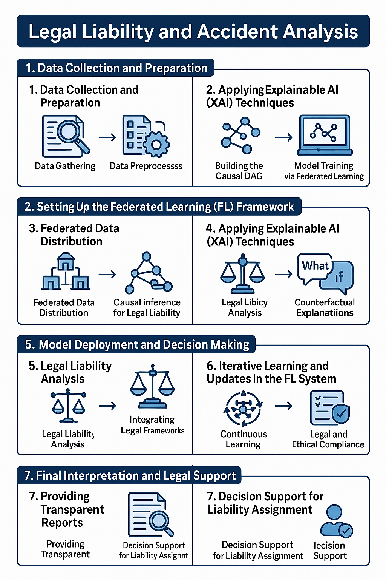

# Computational Advertising and Marketing Lift

**Projects Overview**

Computational advertising utilizes advanced algorithms to automate and optimize the delivery of advertisements, ensuring targeted and efficient outreach. Marketing lift analysis, on the other hand, evaluates the specific impact of marketing initiatives on key performance indicators such as conversions or revenue. This analysis determines whether a campaign or action has a measurable effect on customer behavior by comparing a test group exposed to the campaign with a control group. Causal effect estimators predict the sales outcomes had the ads not been shown, providing a precise assessment of the return on investment (ROI) for digital advertising campaigns.

**Step-by-Step Implementation Process**

Implementing Computational Advertising and Marketing Lift Analysis through Explainable Artificial Intelligence (XAI) with Counterfactual Explanations in Federated Learning (FL) Frameworks, while leveraging Causal Directed Acyclic Graphs (DAGs), can be broken down into a series of key steps. Here's how the process can be outlined:

1. **Data Collection and Preprocessing:**
   * Gather data from diverse sources, such as user interactions with ads, purchase history, and demographic information.
   * Preprocess the data to ensure it's clean, normalized, and relevant to the marketing objectives.
   * Split the data into test and control groups to measure the impact of marketing interventions (such as ad exposure).
2. **Set Up the Federated Learning Framework:**
   * **Federated Learning (FL)** enables distributed learning by training machine learning models on decentralized data without sharing the data itself. In this setup, data from different users or devices is used to train the model, ensuring privacy.
   * Each device (or server) trains a local model based on its data, and periodically shares model updates with a central server to aggregate and improve the global model.
3. **Model Training:**
   * Train machine learning models (e.g., deep learning or gradient boosting models) on the federated data to predict customer behavior, such as the likelihood of conversion or engagement due to ad exposure.
   * This model could predict the impact of ads on users’ decisions, such as predicting if a user would convert based on ad exposure.
4. **Causal Inference with Directed Acyclic Graphs (DAGs):**
   * **Causal Directed Acyclic Graphs (DAGs)** are used to represent the relationships between different variables in the system. In this case, DAGs will represent how various factors (such as ad exposure, user demographics, and historical interactions) influence the outcome (e.g., conversion).
   * The DAG is constructed to capture the causal relationships between ad placement and user response, ensuring that the model does not merely capture correlation but can infer the direction of causality (ad exposure → conversion).
5. **Marketing Lift Estimation:**
   * Estimate the **marketing lift** by comparing the test group (exposed to ads) with the control group (not exposed to ads). The model will calculate the difference in conversion rates between the groups, providing insight into the campaign’s impact.
   * This step involves assessing the **causal effect** of ads on user behavior, which helps determine whether the observed uplift in conversions is truly attributed to the ad exposure.
6. **Counterfactual Explanations:**
   * **Counterfactual explanations** are used to generate explanations for individual predictions. For example, given that a user converted after viewing an ad, a counterfactual explanation might answer: "What would have happened if the user had not been exposed to the ad?"
   * The model uses **counterfactual reasoning** to simulate alternative scenarios where the user was not exposed to the ad, providing insights into the potential outcome under different conditions.
   * These counterfactuals are generated using the **causal DAG**, ensuring that the explanations are rooted in the model’s understanding of causal relationships.
7. **Explainability with XAI Techniques:**
   * To make the model's decision-making process interpretable, use XAI techniques such as **SHAP (Shapley Additive Explanations)** or **LIME (Local Interpretable Model-agnostic Explanations)** to provide human-understandable explanations of individual predictions.
   * These techniques help marketers understand which factors (e.g., specific ad placements, user characteristics) contributed most to the model's prediction of user conversion or engagement.
8. **Impact Assessment and ROI Calculation:**
   * With the causal effect estimated and counterfactual explanations provided, assess the **return on investment (ROI)** for the advertising campaign.
   * Use the model's predictions to calculate how much revenue or conversion would have occurred without the ad exposure, and compare it to the actual results with the ad. This allows a more precise evaluation of the ad's effectiveness.
9. **Iterative Model Refinement and Improvement:**
   * Continuously refine the model by incorporating feedback and new data from ongoing campaigns, ensuring that the model adapts to changing user behavior and marketing tactics.
   * Use federated learning to update the global model across devices without compromising user data privacy, allowing for ongoing optimization.
10. **Deployment and Decision-Making:**

* Once the model has been trained, validated, and explained, deploy it into a live environment where it can make real-time predictions about the effectiveness of new ads or marketing campaigns.
* The insights from the causal analysis and counterfactual explanations can then guide future advertising strategies, helping marketers optimize ad placements and improve campaign performance.

**Summary:**

This step-by-step process integrates Computational Advertising, Marketing Lift Analysis, Federated Learning (FL), Causal DAGs, and Explainable AI (XAI) techniques. By using counterfactual explanations and causal modeling, the system not only predicts and optimizes ad delivery but also provides a transparent understanding of how different variables influence user behavior, enabling more informed decision-making and a clearer assessment of ROI.

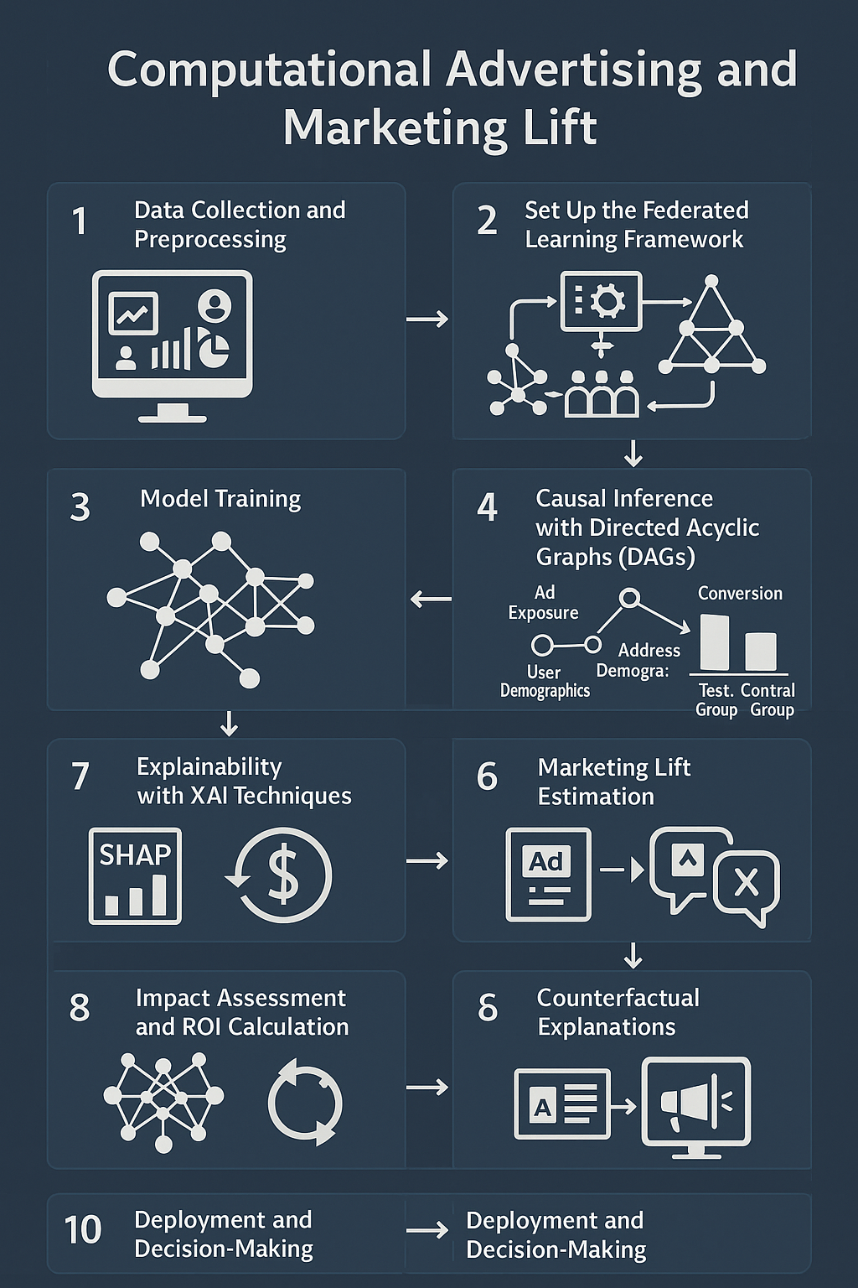

# Cognitive Behavioural Therapy (CBT)

**Projects Overview**

Cognitive Behavioral Therapy (CBT) effectively mitigates regret by offering strategies to address and manage unhealthy thought patterns and emotions, fostering more positive outcomes. This therapeutic approach involves identifying and modifying negative thought processes related to past events and actions, ultimately reducing the intensity and emotional impact of regret. Additionally, other therapeutic modalities, such as Acceptance and Commitment Therapy (ACT), can also play a significant role in managing and coping with regret.

**Step-by-Step Implementation Process**

Implementation of Cognitive Behavioral Therapy (CBT) using Explainable AI (XAI) with Counterfactual Explanations in Federated Learning (FL) Frameworks Using Causal Directed Acyclic Graphs (DAGs):

The combination of Cognitive Behavioral Therapy (CBT) techniques and Explainable AI (XAI) with Counterfactual Explanations in Federated Learning (FL) frameworks, enhanced by Causal Directed Acyclic Graphs (DAGs), presents an advanced approach to personalized mental health treatment. Here's a step-by-step breakdown of how this can be implemented:

**Step 1: Identify the Regret and Negative Cognitive Patterns**

* **CBT Step**: In CBT, the first step is to help individuals identify negative thinking patterns related to past events (e.g., regret about a decision or action).
* **XAI Framework**: Using AI models, you can extract the underlying causes of regret by analyzing user responses and behaviors through data inputs.
* **Federated Learning**: FL allows this process to be done across distributed data sources (e.g., multiple user devices) without compromising privacy, ensuring each participant's data remains localized.

**XAI Role**: XAI models can provide interpretability to help identify the thought patterns or behaviors linked to the feeling of regret. These models generate **counterfactual explanations**, which explain what could have happened differently if a person had made an alternative choice.

**Step 2: Building Causal Models with Directed Acyclic Graphs (DAGs)**

* **CBT Step**: The therapist helps the individual understand the connections between thoughts, emotions, and behaviors.
* **XAI & DAG**: Causal Directed Acyclic Graphs (DAGs) are used to model the relationships between these factors. For example, regret may be linked to negative thoughts about past actions, leading to anxiety or depression.

**XAI Role**: The DAG provides a clear visualization of these cause-and-effect relationships, which helps in understanding the mental health dynamics at play. This can then be integrated into a Federated Learning framework, where each participant's data contributes to building and refining the DAGs without sharing their personal data.

**Step 3: Modeling Alternative Scenarios (Counterfactual Explanations)**

* **CBT Step**: CBT encourages individuals to challenge their negative thinking by considering alternative, more positive outcomes from past actions. This helps reframe regret in a more constructive way.
* **XAI with Counterfactual Explanations**: Counterfactual explanations are a core component here. For instance, given a particular regretful event, counterfactuals could explain what would have happened if the person had taken a different action, leading to a less regretful outcome.

**Federated Learning**: FL allows these counterfactual models to be trained on decentralized data. Each user contributes to the model's development by sharing insights from their personal experience (e.g., reflections on past choices), but the data itself is never shared.

**Step 4: Personalized Feedback and Decision-Making Support**

* **CBT Step**: After identifying negative patterns and presenting alternative outcomes, the therapist works with the individual to develop healthier coping strategies. The individual may also receive cognitive restructuring tools to reframe regret in more adaptive ways.
* **XAI Role**: The XAI system can generate personalized feedback based on the individual’s responses, explaining the reasoning behind suggested coping strategies.
* **Federated Learning**: The FL system ensures that all personalized feedback is based on collective knowledge learned from multiple individuals, preserving privacy while offering robust, data-driven support.

**Causal DAGs** play a critical role in this feedback process, ensuring that the relationships between thoughts, behaviors, and emotions are accurately reflected, and that feedback is both relevant and effective for each user.

**Step 5: Continuous Learning and Model Refinement**

* **CBT Step**: Over time, as individuals practice new cognitive strategies, their thoughts and behaviors evolve. Continuous monitoring and adjustment of the therapeutic approach is essential.
* **XAI with FL**: The system continually learns from user interactions, adjusting its models and counterfactual explanations based on new data, allowing it to refine its therapeutic recommendations.
* **Causal DAGs in FL**: In FL, the causal DAGs evolve as new insights are gathered, and these models are refined using aggregated, non-sensitive data across participants.

**Federated Learning** allows for these updates without sharing private data, ensuring that models are robust while maintaining confidentiality.

**Step 6: Evaluation and Adjustment of Treatment**

* **CBT Step**: Periodic evaluation ensures the therapeutic approach is working and that the person is feeling less regretful and more able to adopt healthier cognitive patterns.
* **XAI Role**: Using counterfactuals, the XAI model can offer detailed assessments on the effectiveness of previous interventions and suggest modifications to the strategies.
* **Federated Learning**: The federated learning framework helps track how well the therapy is working for individuals across various settings, refining the models for better accuracy and relevance in future interventions.

**Summary of Key Components:**

1. **Cognitive Behavioral Therapy (CBT)**: Identifying and modifying negative thought patterns associated with regret.
2. **Explainable AI (XAI)**: Offering counterfactual explanations to illustrate alternative outcomes and help individuals reframe regretful events.
3. **Federated Learning (FL)**: Ensuring privacy by allowing data to remain decentralized while still training models on aggregate data.
4. **Causal Directed Acyclic Graphs (DAGs)**: Modeling causal relationships between thoughts, emotions, and behaviors to understand and address regret.

Through this combined approach, individuals can receive personalized, data-driven therapeutic interventions that evolve over time, empowering them to manage regret and other negative emotions more effectively.

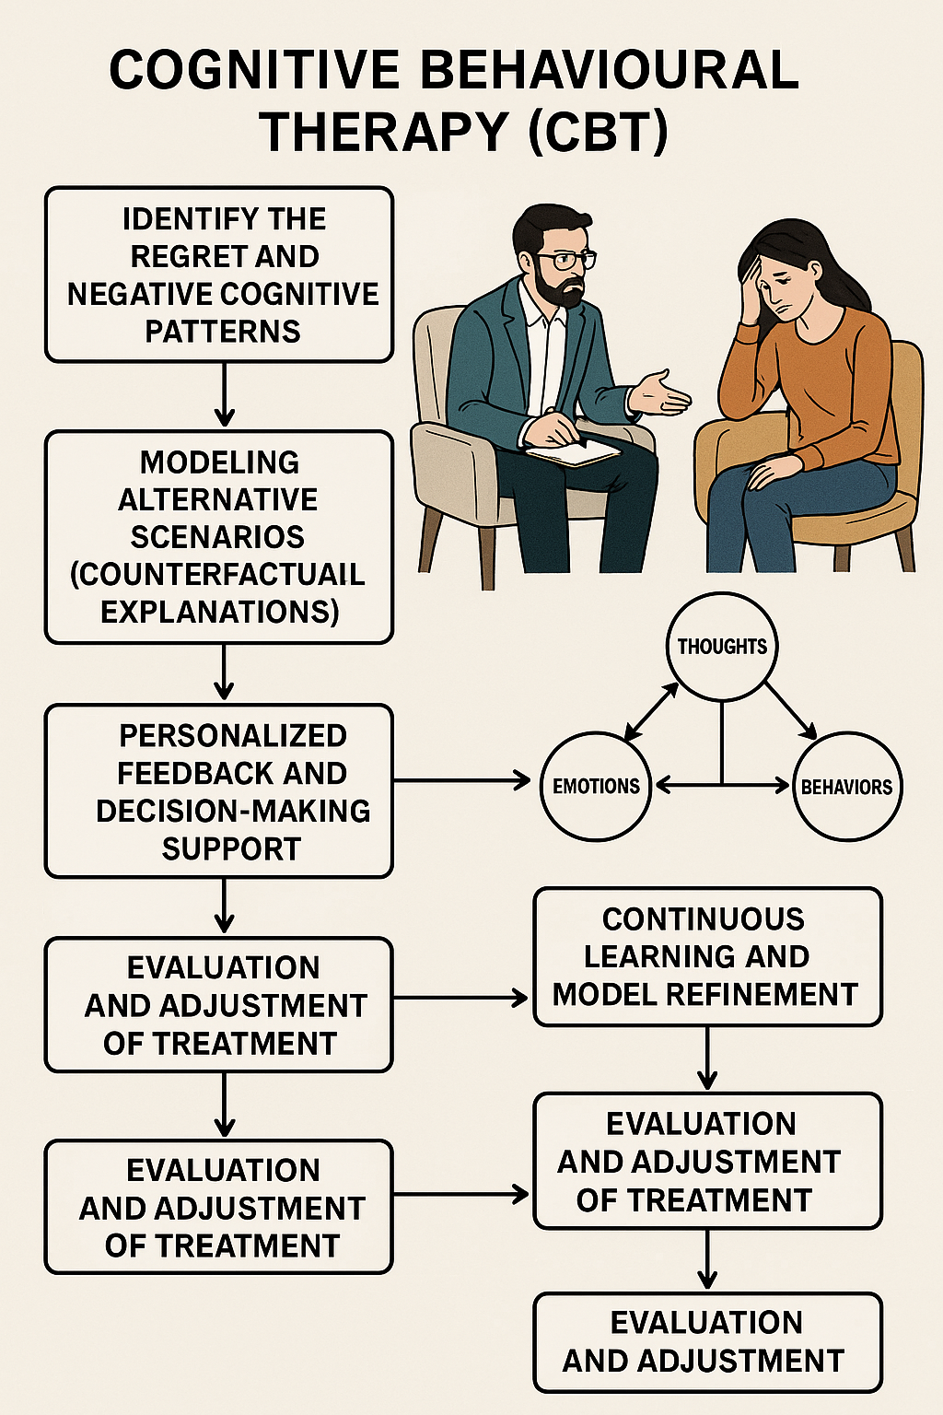

# Supply-Chain Risk Management

**Projects Overview**

Supply Chain Risk Management (SCRM) focuses on identifying, assessing, and mitigating risks across the entire supply chain, from raw material sourcing to the delivery of finished products. This includes evaluating risks related to suppliers, logistics, and distribution networks. The primary objective of SCRM is to ensure business continuity, safeguard profitability, and protect against potential disruptions. By analyzing factors such as supplier delays or port closures, SCRM helps identify key risks that could lead to order disruptions, enabling the implementation of proactive mitigation strategies to minimize impact.

**Step-by-Step Implementation Process**

Implementation of Supply Chain Risk Management (SCRM) using Explainable Artificial Intelligence (XAI) with Counterfactual Explanations in Federated Learning (FL) Frameworks using Causal Directed Acyclic Graphs (DAGs):

The integration of Explainable Artificial Intelligence (XAI) with Counterfactual Explanations in a Federated Learning (FL) framework, supported by Causal Directed Acyclic Graphs (DAGs), provides a powerful way to implement Supply Chain Risk Management (SCRM). This approach enables transparency and understanding of complex risks across the supply chain and allows organizations to proactively address potential disruptions.

**Step 1: Data Collection and Federation**

* **Data Collection**: Gather data from various sources, including suppliers, logistics, production, and distribution networks. Data can include delivery times, supplier performance, weather conditions, geopolitical events, and past disruptions.
* **Federated Learning (FL)**: Rather than centralizing the data, the data remains on local devices or servers across different stakeholders (e.g., suppliers, logistics providers). Each participant trains a local model and shares only the model updates, preserving data privacy.

**Step 2: Causal Directed Acyclic Graph (DAG) Construction**

* **DAG Model**: Construct a Directed Acyclic Graph (DAG) that represents causal relationships within the supply chain. The nodes in the graph represent variables such as supplier delays, logistics disruptions, raw material shortages, and external factors (e.g., port closures).
* **Causal Relationships**: Identify how different supply chain elements are interconnected. For instance, a delay from a supplier may cause a delay in logistics, which affects the delivery of finished goods. These relationships are depicted in the DAG to model potential disruptions and their ripple effects.

**Step 3: Model Training using Federated Learning**

* **Training on Local Data**: Each node in the federated network trains a local model on the supply chain data it owns. For example, a supplier can train its model using historical performance data, while a logistics company can train its model using shipping delay data.
* **Model Aggregation**: The trained local models are aggregated into a global model without the need for sharing raw data. This global model captures the collective knowledge from all participants in the supply chain, maintaining privacy while improving model performance.

**Step 4: Risk Prediction and Assessment**

* **Risk Identification**: Using the trained model, the system predicts potential risks in the supply chain, such as delays, shortages, or disruptions. These risks are calculated by analyzing various scenarios and using the DAG to understand how different events might propagate through the supply chain.
* **Prediction Factors**: The model accounts for both historical data and real-time inputs, such as sudden changes in demand or unforeseen events (e.g., a port closure or political instability).

**Step 5: Explainability with XAI**

* **Counterfactual Explanations**: To provide transparency, XAI techniques are employed to offer counterfactual explanations. These explanations help stakeholders understand what would have happened if certain supply chain factors had been different. For example, "If the supplier had delivered the raw materials on time, the finished product would have reached the market 3 days earlier."
* **Human-Interpretable Results**: These counterfactual explanations ensure that decision-makers can easily interpret complex AI outputs, allowing them to understand the reasoning behind the model's predictions and take appropriate actions.

**Step 6: Mitigation Strategy Development**

* **Proactive Strategy Design**: Based on the risk predictions and causal relationships identified through the DAG, the system provides actionable insights for mitigating potential disruptions. For example, if a particular supplier is likely to cause delays due to past performance, the system might recommend finding alternative suppliers or adjusting logistics schedules.
* **Scenario Simulation**: Through counterfactual reasoning, the system can simulate different scenarios to show how altering certain variables (e.g., changing suppliers or rerouting shipments) would affect the overall supply chain risk.

**Step 7: Continuous Learning and Adaptation**

* **Model Refinement**: As new data flows in (e.g., real-time updates on supplier performance, shipping delays), the federated learning model is updated in an ongoing process. This allows the supply chain risk management system to adapt to changing conditions.
* **Feedback Loops**: Stakeholders can provide feedback on the model’s predictions and recommendations, further refining the risk management strategies over time.

**Step 8: Decision Support and Risk Communication**

* **Visualization and Dashboards**: The system presents risk predictions and mitigation strategies in a clear and visual format through dashboards. These dashboards, powered by XAI and counterfactual explanations, allow decision-makers to quickly assess the situation and take necessary actions.
* **Stakeholder Communication**: The model's outputs and explanations are communicated to all relevant stakeholders, ensuring that everyone is aware of potential risks and the rationale behind risk management decisions.

**Conclusion:**

By integrating Explainable AI, Counterfactual Explanations, and Federated Learning with Causal DAGs, businesses can enhance their ability to predict, assess, and mitigate risks within their supply chains. This approach not only improves decision-making but also ensures transparency and trust in the automated risk management system, ultimately leading to greater resilience and business continuity.

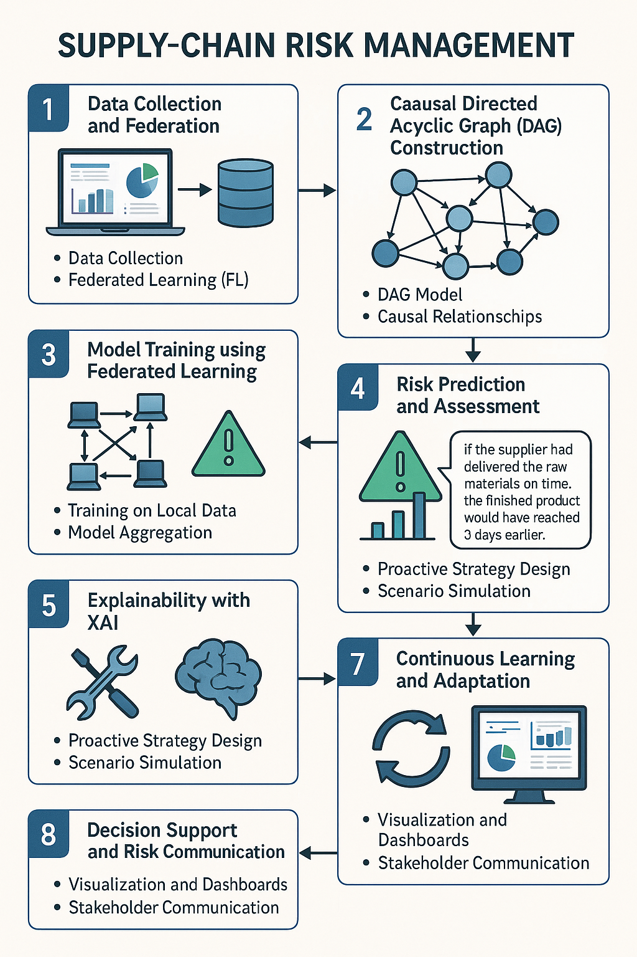

# Network Optimisation in Humanitarian Logistics

**Projects Overview**

This approach aims to enhance the efficiency and effectiveness of aid delivery by optimizing the placement and movement of resources. It involves determining the most strategic locations for warehouses, distribution centers, and other facilities, as well as optimizing the allocation of resources and transportation routes to maximize the impact of relief efforts. The focus is on minimizing costs associated with facility setup, while providing clear justifications for decisions related to facility locations and operations within humanitarian relief efforts.

**Step-by-Step Implementation Process**

Implementing Network Optimization in Humanitarian Logistics Using Explainable AI (XAI) with Counterfactual Explanations in Federated Learning Frameworks and Causal Directed Acyclic Graphs (DAGs)

Network optimization in humanitarian logistics is a complex task that benefits from the integration of advanced machine learning techniques. To achieve a comprehensive and interpretable model, we can employ Explainable Artificial Intelligence (XAI) with counterfactual explanations within a Federated Learning (FL) framework, leveraging causal Directed Acyclic Graphs (DAGs). Here is a step-by-step process to implement this approach:

**Step 1: Problem Definition and Objective Identification**

* **Objective**: The goal is to optimize the placement of warehouses, distribution centers, and transportation routes to maximize the impact of aid delivery while minimizing costs. This involves multiple decision-making aspects, such as optimal resource allocation, location decisions, and transportation logistics.
* **Constraints**: These could include limited budgets, the geographic distribution of populations in need, and the availability of transportation infrastructure.

**Step 2: Data Collection and Federated Learning Setup**

* **Data Sources**: Gather data from various humanitarian organizations (e.g., past logistics operations, geographic data, infrastructure, and population density).
* **Federated Learning**: Set up a Federated Learning framework where data from different stakeholders (e.g., NGOs, government bodies) remains decentralized. Each organization can train its own model locally, and then only share model updates (not raw data) with a central server, preserving privacy.
* **Data Preprocessing**: Ensure data normalization and standardization to make it suitable for machine learning models.

**Step 3: Causal Modeling Using Directed Acyclic Graphs (DAGs)**

* **DAG Construction**: Build a causal Directed Acyclic Graph (DAG) to represent relationships between variables such as the placement of warehouses, resource availability, and transportation routes. The nodes in the DAG represent the decision variables, and the edges represent the causal dependencies between them.
* **Causal Inference**: Use the DAG to infer causal relationships between different logistical factors (e.g., how the location of a warehouse influences the efficiency of resource distribution). This helps in understanding the impact of various decisions in the humanitarian logistics network.

**Step 4: Optimization Algorithm Development**

* **Objective Function**: Develop an optimization algorithm that takes into account the various factors and constraints identified in the problem definition. This algorithm aims to minimize the cost of opening distribution centers and transporting resources while maximizing the overall impact of aid delivery.
* **Machine Learning Model**: Train a machine learning model (e.g., reinforcement learning or deep learning) that uses data from the federated network to predict the most efficient logistics decisions.
* **Incorporation of DAGs**: The DAG can guide the model by indicating causal relationships that need to be considered in the optimization process. The algorithm should adjust based on both historical data and inferred causal dependencies.

**Step 5: Explainable AI (XAI) Integration**

* **Model Interpretability**: Integrate XAI techniques into the machine learning model to ensure transparency and understanding of how decisions are being made. This can include using models like SHAP (Shapley Additive Explanations) or LIME (Local Interpretable Model-agnostic Explanations) to provide insights into the decision-making process.
* **Counterfactual Explanations**: Provide counterfactual explanations to decision-makers by answering questions such as, "What would have happened if a different distribution center location had been chosen?" This helps stakeholders understand how different decisions affect the outcome and provides insights into potential improvements.

**Step 6: Simulation and Scenario Testing**

* **Simulation**: Run simulations with the trained model to test the network optimization in different scenarios, such as varying transportation costs, unexpected demand surges, or resource shortages.
* **Scenario Analysis**: Use the counterfactual explanations to show how the model would have acted under different conditions, helping to identify potential areas for improvement in logistics planning.
* **Feedback Loop**: Continuously update the model using feedback from real-world operations, allowing for ongoing improvement of the optimization process.

**Step 7: Real-time Implementation and Decision Support**

* **Deployment**: Deploy the optimized network in real-world humanitarian operations, using the Federated Learning framework to keep all participants’ models synchronized without sharing sensitive data.
* **Decision Support System**: Implement a decision support system where stakeholders can input real-time data and receive optimized recommendations for logistics decisions (e.g., warehouse locations, transportation routes). The system would also provide clear, interpretable explanations for the recommendations based on the XAI framework.

**Step 8: Continuous Monitoring and Adaptation**

* **Monitoring**: Continuously monitor the performance of the logistics network using performance metrics such as cost reduction, delivery speed, and overall aid impact.
* **Adaptation**: Regularly update the model with new data and feedback, adjusting the optimization strategy as necessary. The XAI framework will ensure that all changes are interpretable and justifiable to stakeholders.

**Step 9: Final Insights and Reporting**

* **Reporting**: Generate detailed reports showing the effectiveness of the optimized logistics network, including cost savings, delivery efficiency, and impact. These reports should also include XAI-based explanations of how the decisions were made, providing transparency and accountability.

By leveraging Explainable AI with counterfactual explanations, Federated Learning, and causal DAGs, this approach ensures that humanitarian logistics operations are not only optimized but also transparent and justifiable, aiding decision-makers in understanding the underlying reasons for each choice and its potential impact.

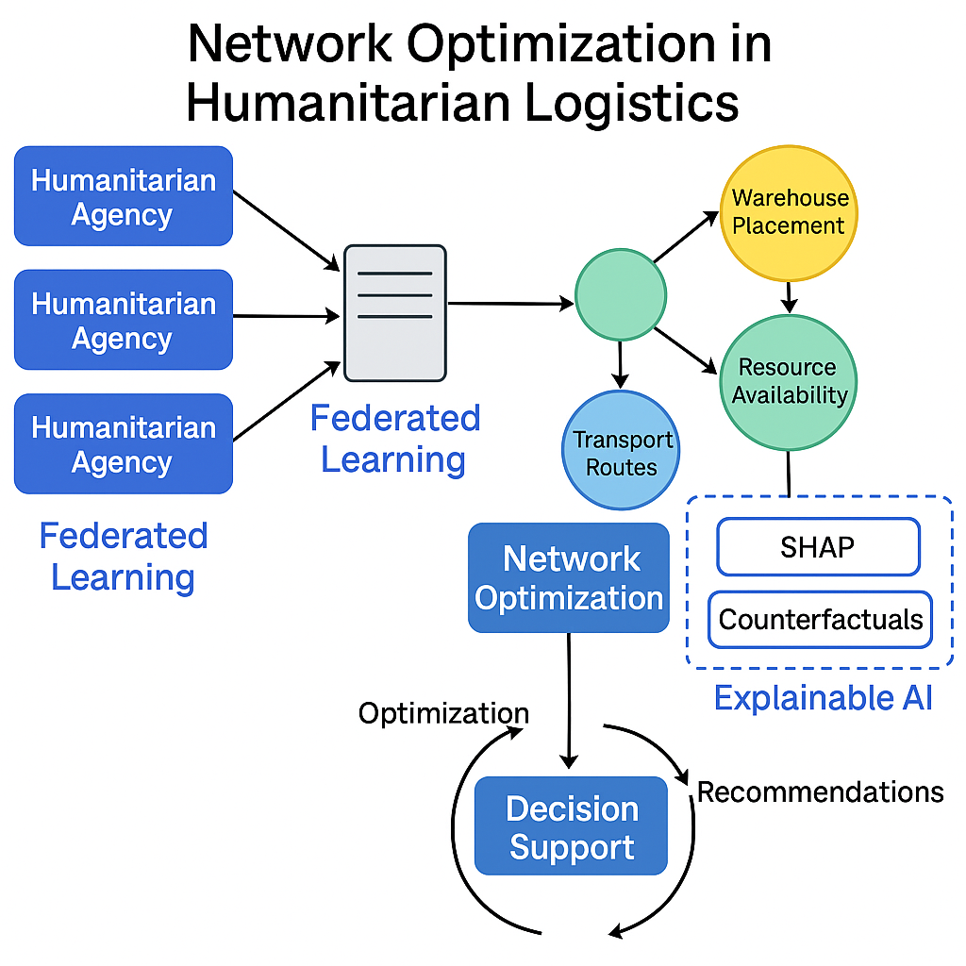

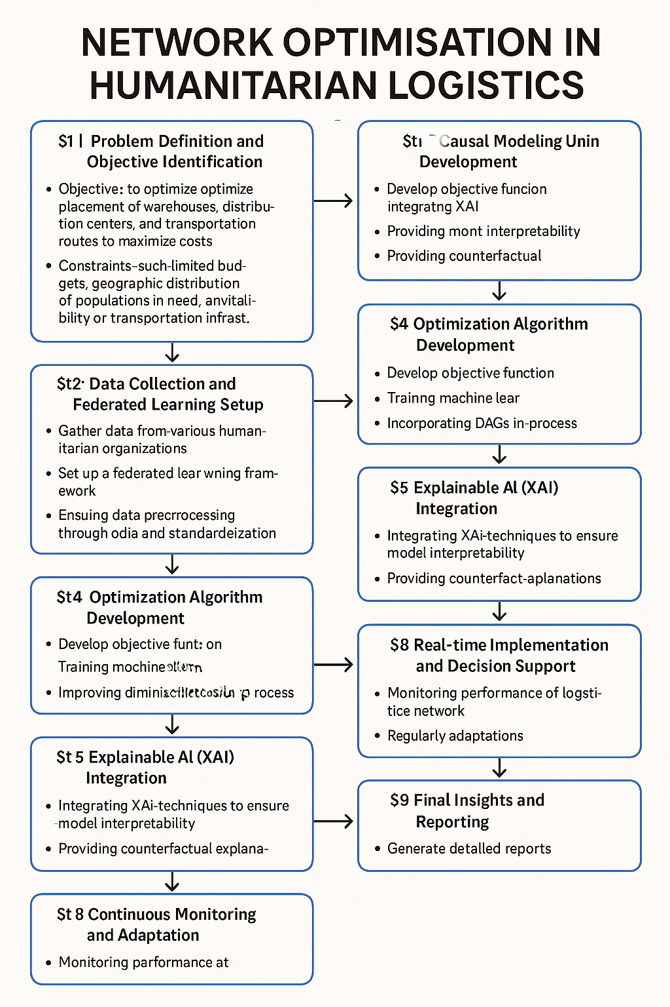

# Educational Policy Evaluation

**Projects Overview**

Educational policy evaluation involves the systematic collection and analysis of data to assess whether a policy is meeting its intended objectives, identifying any unintended consequences, and guiding future policy decisions. This process can be carried out throughout the entire policy cycle, from the initial design phase to implementation and subsequent stages. Counterfactual models are used to estimate how student performance would change under different curricula, providing valuable insights for adaptive learning and resource allocation in educational institutions. By determining which instructional methods and resources have a causal impact on student performance, these evaluations contribute to the optimization of adaptive learning systems.

**Step-by-Step Implementation Process**

Implementing educational policy evaluation using Explainable Artificial Intelligence (XAI) with counterfactual explanations within Federated Learning (FL) frameworks, particularly using causal Directed Acyclic Graphs (DAGs), can be broken down into a series of steps as follows:

**1. Data Collection and Preprocessing**

* **Objective:** Gather data from multiple educational institutions to analyze the impact of various policies on student performance.
* **Data Sources:** This could include student test scores, attendance records, curriculum details, teacher profiles, resource allocation, and other relevant metrics.
* **Preprocessing:** Clean and preprocess data to ensure it's suitable for modeling, handling missing values, scaling features, and encoding categorical variables.

**2. Federated Learning Setup**

* **Objective:** Set up a federated learning framework to enable collaboration across multiple educational institutions while ensuring data privacy and security.
* **Process:**
  + Each institution trains its local model based on the data it possesses.
  + Model updates (e.g., gradients) are sent to a central server for aggregation, without sharing raw data. This enables joint learning while keeping data local and confidential.
* **Benefit:** Ensures that sensitive student data remains private and complies with data protection regulations.

**3. Causal Modeling with Directed Acyclic Graphs (DAGs)**

* **Objective:** Build a causal model to understand the relationships between variables, such as instructional methods, resource allocation, and student performance.
* **Process:**
  + Construct a **Directed Acyclic Graph (DAG)** where nodes represent variables (e.g., instructional methods, student performance), and edges represent causal relationships.
  + Use statistical or machine learning techniques to infer causal links from the data.
  + DAGs help in understanding the **causal structure**, which is essential for determining which factors influence student performance and which educational policies are most effective.

**4. Counterfactual Modeling**

* **Objective:** Estimate how student performance would differ under different scenarios or policy interventions, enabling policy decision-making.
* **Process:**
  + Use counterfactual models to simulate **what-if** scenarios (e.g., "What would student performance be if a different curriculum was implemented?").
  + These models generate predictions of student performance under alternative conditions, which helps in evaluating the impact of different policies without the need for real-world experimentation.
  + The counterfactual explanations can be generated using causal inference methods, leveraging the DAG to understand the changes in outcomes.

**5. Explainable AI (XAI) Integration**

* **Objective:** Ensure that the decision-making process is transparent and interpretable.
* **Process:**
  + Implement XAI techniques like **LIME** (Local Interpretable Model-Agnostic Explanations) or **SHAP** (SHapley Additive exPlanations) to explain model predictions in an understandable way.
  + Use XAI to provide **counterfactual explanations**, helping policymakers understand how changing certain inputs (e.g., teaching methods or resources) would have affected student outcomes.
  + This level of transparency allows stakeholders to trust the model and make informed decisions based on the predictions.

**6. Model Evaluation and Validation**

* **Objective:** Evaluate the performance of the model and validate its predictions against real-world data.
* **Process:**
  + Use traditional evaluation metrics such as **accuracy**, **precision**, **recall**, and **F1 score**, along with causal metrics (e.g., **causal impact** analysis) to assess the effectiveness of the policy.
  + Cross-validate the model across different institutions or datasets to ensure generalizability and robustness.
  + Use XAI to ensure that the model’s explanations align with known educational theories or real-world expectations.

**7. Policy Recommendations**

* **Objective:** Provide actionable insights to improve educational policies.
* **Process:**
  + Based on the counterfactual analyses and causal insights, recommend the most effective instructional methods, resource allocation strategies, or curriculum changes.
  + Use the results from the XAI framework to present these recommendations in an interpretable way, enabling stakeholders to make data-driven decisions.

**8. Adaptive Learning and Resource Allocation**

* **Objective:** Implement the evaluated and optimized policies to improve educational outcomes.
* **Process:**
  + Based on the model’s insights, adapt learning environments to support policies that are likely to improve student performance.
  + Allocate resources dynamically to areas that have the greatest impact on learning outcomes, using the feedback from the counterfactual models and XAI explanations.

**9. Continuous Monitoring and Improvement**

* **Objective:** Monitor the effectiveness of the implemented policies and refine the models over time.
* **Process:**
  + Continuously collect data on student performance and institutional metrics.
  + Update the federated learning model with new data to improve the model’s accuracy and adapt to changes in the educational environment.
  + Use ongoing counterfactual analysis and XAI to assess how the current policies are performing and make further adjustments as necessary.

**Summary**

This process combines **Federated Learning**, **Causal DAGs**, **Counterfactual Modeling**, and **Explainable AI** to provide a comprehensive approach for evaluating and optimizing educational policies. By using these advanced techniques, educational institutions can make data-driven decisions that are transparent, interpretable, and more likely to lead to improved student performance and better resource allocation.

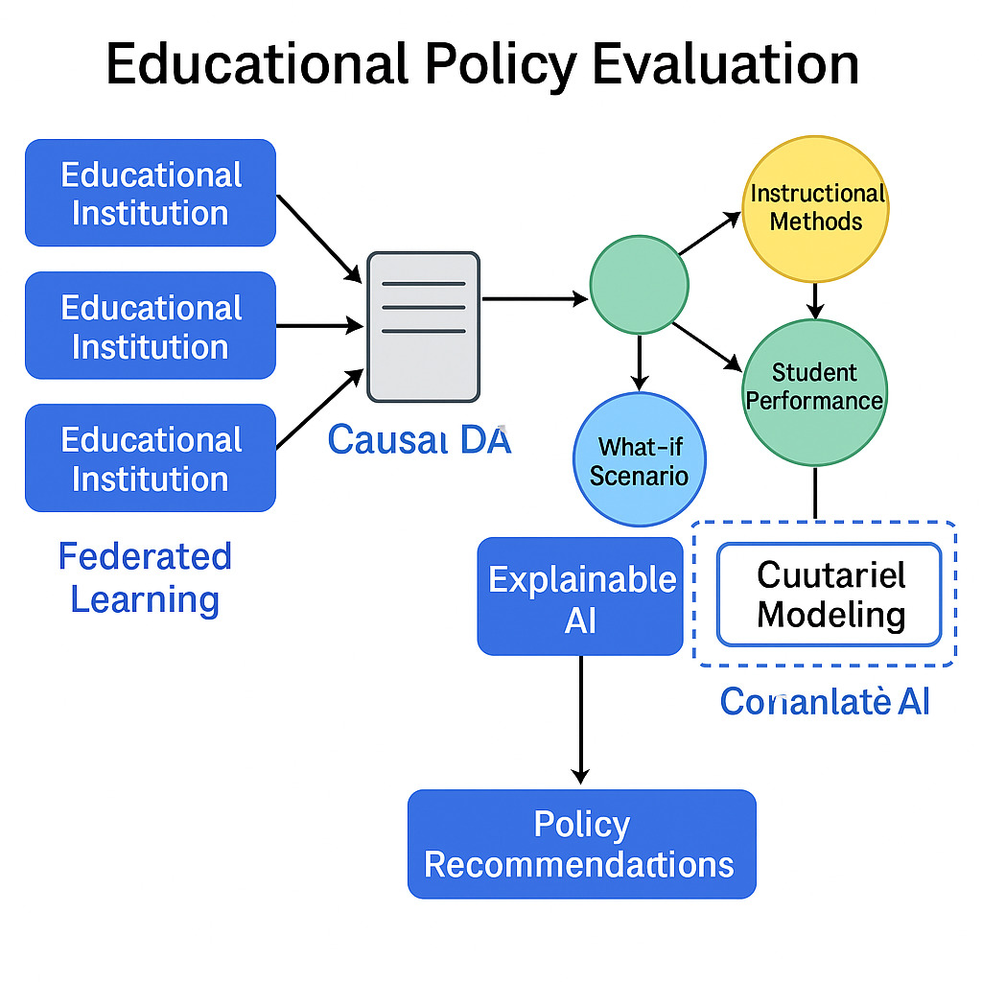

# Public Health Program Evaluation

**Projects Overview**

Public Health Program Evaluation is a structured process aimed at assessing the effectiveness, efficiency, and impact of public health interventions. This process involves the systematic collection, analysis, and interpretation of data to determine the success of interventions, identify areas for improvement, and ensure that program objectives are being met. The primary goal is to enhance program quality and outcomes, while also providing accountability and justifying the allocation of continued funding.

**Step-by-Step Implementation Process**

Implementing Public Health Program Evaluation using Explainable Artificial Intelligence (XAI) with Counterfactual Explanations in Federated Learning (FL) frameworks, combined with Causal Directed Acyclic Graphs (DAGs), can enhance the transparency and interpretability of decision-making processes. Here’s a step-by-step breakdown of how this can be done:

**1. Define the Public Health Program and Evaluation Metrics**

* **Identify Intervention and Outcomes**: Start by clearly defining the public health intervention(s) and desired outcomes (e.g., disease prevention, improved health metrics).
* **Key Evaluation Metrics**: Establish the metrics that will be used to evaluate the success of the program, such as health improvements, cost-effectiveness, or community engagement levels.

**2. Data Collection and Preprocessing**

* **Federated Learning Data Collection**: In an FL setup, health data from multiple institutions or organizations (e.g., hospitals, clinics, or public health bodies) are securely collected without the need for centralized storage.
* **Data Privacy and Security**: Ensure that all collected data adheres to privacy regulations such as HIPAA or GDPR.
* **Data Preprocessing**: Clean the data and ensure it's in a suitable format for analysis, handling missing values, and transforming features appropriately.

**3. Federated Learning Framework Setup**

* **Model Distribution**: Implement the federated learning framework where the machine learning model is trained locally at each data source (e.g., a hospital) without transferring raw data. This prevents data leakage and enhances privacy.
* **Collaborative Training**: The global model is updated iteratively by aggregating local model updates from each participating entity.
* **Model Aggregation**: Use techniques like Federated Averaging to aggregate local models into a global model without compromising data privacy.

**4. Use of Causal Directed Acyclic Graphs (DAGs)**

* **Causal Modeling**: Construct a Directed Acyclic Graph (DAG) to represent the relationships between variables in the public health program. For example, DAGs can model the causal relationships between interventions (e.g., vaccination programs) and health outcomes (e.g., reduced disease prevalence).
* **Identifying Confounding Factors**: The DAG helps identify confounders (variables that affect both the intervention and outcome), enabling the evaluation of causal effects without bias.

**5. Explainable AI (XAI) for Model Interpretation**

* **Model Explainability**: After training the model using FL, apply XAI techniques to interpret the model’s predictions. For example, feature importance can help identify which factors most influence health outcomes.
* **Counterfactual Explanations**: Generate counterfactual explanations to explain the impact of different interventions. For instance, a counterfactual explanation might show how the outcome would change if a certain action (e.g., increasing vaccination rates) had been taken.
* **Transparency**: The use of XAI ensures that health professionals, policymakers, and stakeholders can understand and trust the model’s decision-making process.

**6. Evaluation and Assessment of Program Impact**

* **Evaluate Program Performance**: Using the trained FL model, evaluate the effectiveness of the public health program. This includes assessing how the intervention has impacted the health metrics and comparing the predicted outcomes with actual outcomes.
* **Identify Improvements**: With the help of counterfactual explanations, determine which factors could have led to better outcomes if adjusted. For example, "If the vaccination rate had been 10% higher, disease cases would have decreased by 5%."

**7. Iterative Refinement and Feedback**

* **Refine Intervention Strategies**: Based on insights from counterfactual explanations and causal modeling, adjust the intervention strategies. This could involve changing targeting strategies, resource allocation, or outreach methods.
* **Update Model**: Regularly update the federated model to incorporate new data and improve predictions. This ensures that the model reflects ongoing changes in public health dynamics.

**8. Reporting and Stakeholder Engagement**

* **Comprehensive Reporting**: Create detailed reports summarizing the evaluation process, key findings, and actionable recommendations. Use the XAI outputs to present understandable and transparent results to stakeholders.
* **Decision-Making**: Facilitate informed decision-making by presenting counterfactuals and causal relationships, allowing stakeholders to understand the 'what if' scenarios and plan accordingly.

**9. Policy and Funding Justification**

* **Justify Continued Funding**: Use the evidence from the evaluation, supported by causal modeling and counterfactual analysis, to justify the continuation or expansion of the public health program.
* **Accountability**: The transparency provided by XAI and causal DAGs ensures accountability, as all stakeholders can verify the effectiveness of the program and its impact on health outcomes.

**Summary:**

This approach integrates advanced AI techniques to enhance the interpretability and transparency of public health program evaluation. By combining Federated Learning, Causal DAGs, and Explainable AI, with counterfactual reasoning, the process provides clear insights into what works, why it works, and how improvements can be made, all while respecting data privacy and enhancing decision-making in public health.

# Finance: Credit Assessment and Risk Management

**Projects Overview**

Credit assessment and risk management are fundamental processes in finance aimed at evaluating a borrower's ability to repay debt and minimizing potential financial losses. These processes involve comprehensive analysis of a borrower's creditworthiness, continuous performance monitoring, and strategic management of credit risk through various methodologies.

**Credit Assessment** entails the thorough evaluation of a borrower's financial history, credit scores, income levels, and overall capacity to meet repayment obligations. This assessment is critical for determining the borrower’s reliability and suitability for receiving credit.

**Risk Management** focuses on developing and applying models and techniques that assess and mitigate credit risk. This includes setting appropriate loan terms, interest rates, and other conditions based on the assessed risk level. Risk management strategies also involve understanding the factors contributing to loan defaults and market fluctuations, with the aim of enhancing credit scoring models and improving risk mitigation practices.

Together, these processes ensure sound lending decisions and effective management of financial risk.

**Step-by-Step Implementation Process**

Implementation of Credit Assessment and Risk Management Using Explainable AI (XAI) with Counterfactual Explanations in Federated Learning (FL) Frameworks with Causal Directed Acyclic Graphs (DAGs)

Implementing credit assessment and risk management in finance using Explainable Artificial Intelligence (XAI), Counterfactual Explanations, and Federated Learning (FL) frameworks with Causal Directed Acyclic Graphs (DAGs) involves a series of structured steps to ensure accurate and transparent decision-making while maintaining privacy and reducing risk. Below is a general step-by-step process for implementing this:

**Step 1: Data Collection and Preprocessing**

* **Data Sources**: Collect data from multiple decentralized sources such as banks, financial institutions, or credit bureaus. This data can include information about borrowers' credit history, financial records, income, debt levels, and payment history.
* **Preprocessing**: Normalize and clean the data to remove inconsistencies, outliers, or missing values. Feature engineering may be applied to create relevant attributes like debt-to-income ratio, credit utilization, etc.

**Step 2: Federated Learning Model Setup**

* **Federated Learning (FL)**: In this step, a federated learning framework is established to train the model without sharing sensitive data between institutions. Each institution (e.g., a bank) trains a local model using its own data and sends only model updates (weights, gradients) to a central server. This ensures privacy as data is not exchanged directly.
* **Global Model**: A global model is aggregated from the local models through techniques like Federated Averaging (FedAvg). The global model combines insights from different datasets to make more accurate predictions without violating data privacy.

**Step 3: Credit Assessment Model**

* **Model Design**: A credit assessment model, such as a machine learning model (e.g., Random Forest, SVM, or Deep Neural Networks), is used to predict the borrower’s creditworthiness. Features include the borrower’s credit score, income, past loan performance, and current financial status.
* **Training**: Using FL, the model is trained on each institution's data, ensuring that all data is kept locally. The aggregated updates from different institutions are used to improve the model iteratively.

**Step 4: Risk Assessment Model Development**

* **Risk Evaluation**: Develop a model to assess the level of credit risk associated with the borrower. This includes setting loan terms, interest rates, and terms based on the risk level predicted by the model.
* **Model Updates**: The model updates are calculated in each institution and sent to the central server to build a more generalized, accurate risk assessment system that accounts for variations in data from different regions or institutions.

**Step 5: Causal Analysis Using Directed Acyclic Graphs (DAGs)**

* **Causal DAG Construction**: Construct causal Directed Acyclic Graphs (DAGs) to model the relationships between different variables in the credit assessment process (e.g., income, credit score, loan amount). The DAGs help identify direct and indirect influences on the borrower’s creditworthiness and potential risks.
* **Identifying Causal Relationships**: The DAGs help uncover hidden relationships and dependencies between variables, such as how income influences credit score or how a borrower’s financial behavior leads to loan default. This analysis aids in understanding and interpreting the factors contributing to risk.

**Step 6: Explainable AI (XAI) Integration**

* **XAI Models**: Incorporate XAI techniques like SHAP (Shapley Additive Explanations), LIME (Local Interpretable Model-agnostic Explanations), or counterfactual explanations to make the model’s predictions interpretable. These techniques provide transparency by explaining why a specific loan approval or rejection decision was made based on the borrower’s data.
* **Counterfactual Explanations**: Provide counterfactual explanations to answer questions like, “What would have happened if the borrower’s income were higher, or if the borrower’s credit history was better?” This helps decision-makers understand the key factors that influence credit decisions and improves the interpretability of the model.

**Step 7: Monitoring and Risk Mitigation**

* **Continuous Monitoring**: Regularly monitor the performance of the federated model using updated data from the institutions. This includes tracking loan default rates, repayment trends, and any emerging risk factors.
* **Risk Adjustment**: Based on the ongoing monitoring, update the model periodically to reflect the evolving financial environment, borrower behavior, and market conditions.

**Step 8: Feedback Loop and Refinement**

* **Feedback Collection**: Collect feedback from financial institutions regarding the model’s performance, accuracy, and the explanations provided. Adjust the model as needed based on real-world outcomes.
* **Iterative Improvement**: Use the feedback and new data to continuously refine both the credit assessment and risk management models. This ensures that the models adapt to changing economic conditions and remain effective in managing credit risk.

**Step 9: Regulatory Compliance and Ethical Considerations**

* **Regulatory Adherence**: Ensure that the implemented models comply with relevant regulations such as GDPR, Fair Lending Laws, and other data protection regulations. Data privacy and security must be maintained in the federated learning framework.
* **Ethical Considerations**: Monitor for any biases in the models (e.g., biases related to gender, ethnicity, or socio-economic status) and address them by ensuring fairness and transparency in both credit and risk assessment.

By following this process, financial institutions can leverage XAI, Federated Learning, Counterfactual Explanations, and Causal DAGs to build transparent, accurate, and privacy-preserving credit assessment and risk management systems. These approaches not only enhance decision-making but also foster trust and compliance with regulatory standards.

# Marketing: Promotion Lift Analysis

**Projects Overview**

Promotion Lift Analysis is a marketing technique used to assess the incremental impact of a marketing campaign or promotional activity on key metrics such as sales, conversions, or brand awareness. This approach compares the performance of a control group (which is not exposed to the campaign) with a treatment group (which is exposed to the campaign) to measure the actual lift, or increase, in the target metric. The goal is to accurately estimate the causal impact of advertising campaigns and promotions on sales, distinguishing genuine lift from trends that may be correlated but not directly attributable to the campaign.

**Step-by-Step Implementation Process**

Implementing Promotion Lift Analysis Using Explainable Artificial Intelligence (XAI) with Counterfactual Explanations in Federated Learning (FL) Frameworks via Causal Directed Acyclic Graphs (DAGs):

1. **Data Collection and Preprocessing:**
   * **Data from Campaigns:** Gather data related to the marketing campaign, including sales, conversions, customer interactions, and any relevant contextual data (e.g., demographics, geographical location).
   * **Control and Treatment Groups:** Identify and segment the control group (not exposed to the campaign) and the treatment group (exposed to the campaign). Ensure data is clean and appropriately preprocessed for analysis.
2. **Model Setup in Federated Learning (FL) Framework:**
   * **Federated Learning Setup:** Implement a federated learning framework where multiple decentralized models are trained across different devices or institutions without exchanging sensitive data. This ensures privacy preservation while leveraging local datasets to train the models.
   * **Local Model Training:** Each local model learns from its dataset, capturing patterns specific to the data it has access to (e.g., data from specific regions or user segments).
   * **Global Model Aggregation:** Periodically, the local models send their parameters to a central server, where they are aggregated into a global model without transferring the raw data, thus enabling joint model training.
3. **Causal Inference with Causal DAGs:**
   * **Constructing Causal DAGs:** Use causal directed acyclic graphs (DAGs) to model the relationships between various factors that might influence sales or conversions, such as campaign exposure, seasonality, customer behavior, and external factors (e.g., economic trends). DAGs help in visualizing and understanding the causal relationships between variables.
     + **Nodes:** Represent variables such as campaign exposure, sales, customer demographics, etc.
     + **Edges:** Indicate direct causal relationships, helping to identify which variables might be confounding factors or causal influencers.
   * **Causal Inference:** Apply causal inference techniques to determine the causal effect of the marketing campaign on the outcome variables. This helps isolate the genuine lift attributable to the campaign, distinguishing it from other correlated trends.
4. **Explainable AI (XAI) Integration:**
   * **Model Explainability:** Implement XAI techniques to make the FL model’s predictions more interpretable. This is critical for understanding how marketing campaigns influence customer behavior and sales.
   * **LIME/SHAP for Feature Attribution:** Use Local Interpretable Model-agnostic Explanations (LIME) or SHAP (SHapley Additive exPlanations) to provide local explanations for specific predictions made by the federated model. These methods help attribute changes in sales or conversions to the relevant features (e.g., exposure to the campaign, seasonality, customer demographics).
5. **Counterfactual Explanations for Causal Lift:**
   * **Counterfactuals:** Generate counterfactual explanations to simulate what would have happened if the treatment group had not been exposed to the campaign (i.e., a counterfactual scenario). By comparing the actual outcome (with the campaign) to the counterfactual outcome (without the campaign), we can estimate the true causal impact or lift.
     + **Example:** If the treatment group had not been exposed to the campaign, how would their sales have changed? The difference between the actual sales and the counterfactual sales represents the true lift.
   * **Counterfactual Reasoning:** Implement counterfactual reasoning within the FL framework by using techniques such as causal effect estimation, where the model learns to predict the outcome of different scenarios (e.g., campaign vs. no campaign) based on the observed data and causal relationships captured in the DAG.
6. **Promotion Lift Analysis Calculation:**
   * **Lift Calculation:** With the aid of the causal DAG and counterfactual explanations, calculate the lift by comparing the sales or conversions in the treatment group to those in the control group, adjusted for confounding factors identified by the DAG.
     + **True Lift (Incremental Impact):** The lift represents the genuine effect of the marketing campaign, adjusting for any other factors influencing the outcome.
     + **Statistical Analysis:** Perform statistical tests (e.g., hypothesis testing, significance testing) to confirm the significance of the observed lift.
7. **Visualization and Reporting:**
   * **Causal Impact Visualization:** Use visualizations like DAGs, counterfactual outcome graphs, and SHAP plots to illustrate the causal effects of the campaign and how different factors contributed to the lift in sales or conversions.
   * **Explainable Reports:** Provide actionable insights and interpretations based on the XAI analysis, enabling marketing teams to understand the drivers of success and areas for optimization.
8. **Feedback Loop and Model Refinement:**
   * **Model Refinement:** Based on the insights from the promotion lift analysis, refine the federated learning models to incorporate additional factors or adjust for unforeseen biases.
   * **Feedback to Campaigns:** Use the findings to improve future marketing campaigns, making data-driven decisions on targeting, message delivery, and resource allocation.

By following this step-by-step process, businesses can accurately assess the true impact of their marketing campaigns using an advanced blend of causal inference, federated learning, and explainable AI techniques, ultimately leading to more informed decisions and optimized promotional strategies.

# Manufacturing: Fault Detection and Root Cause Analysis

**Projects Overview**

Effective fault detection and root cause analysis are essential for ensuring quality, optimizing efficiency, and minimizing costly downtime in manufacturing operations. Root cause analysis plays a pivotal role in identifying the underlying factors contributing to defects or failures, enabling the implementation of targeted solutions that not only resolve the issue but also prevent its recurrence, thereby enhancing overall production performance. Utilizing fault tree analysis allows for the precise identification of component failures that drive system breakdowns, ultimately reducing both downtime and maintenance costs.

Here is a generalized, step-by-step procedure for implementing manufacturing fault detection and root-cause analysis using Explainable AI (XAI) with counterfactual explanations in a Federated Learning (FL) framework, underpinned by causal Directed Acyclic Graphs (DAGs):

By first constructing a causal DAG to represent the interdependencies among process variables, one can leverage a federated learning setup to train local models on decentralized data while preserving privacy. These models are then aggregated into a global model whose predictions are explained via counterfactual reasoning. Counterfactual explanations pinpoint minimal changes in inputs that would alter a fault prediction, and tracing these changes back through the causal DAG reveals underlying root causes. Iterating this loop refines both the model and the causal graph, driving continuous improvement in fault detection accuracy and prevention.

**Step-by-Step Implementation Process**

**1. Causal DAG Construction**

1. **Identify key variables and relationships.**

Map out process parameters (e.g., temperatures, pressures, vibration metrics) and potential failure modes, using domain expertise and historical data to hypothesize causal links.

1. **Build the DAG structure.**

Encode these causal assumptions in a Directed Acyclic Graph, where nodes represent variables and edges denote direct causal influences.

1. **Refine via causal discovery.**

Apply data-driven causal discovery algorithms (e.g., LiNGAM, constraint-based methods) to validate and adjust the graph against observed data.

**2. Federated Learning Model Deployment**

1. **Select an FL framework.**

Choose an open-source platform (e.g., OpenFL) to coordinate decentralized training across multiple sites or machines.

1. **Define the global model architecture.**

Specify a neural network (or other ML model) suitable for fault detection, ensuring compatibility with XAI post-hoc explanation methods.

**3. Local Model Training**

1. **Distribute the initial global model.**

Send model parameters to each participating edge node or factory site, where data privacy is strictly maintained.

1. **Train on local data.**

Each node updates the model using its own production data (sensor readings, maintenance logs), optimizing fault-prediction performance.

**4. Global Model Aggregation**

1. **Collect weight updates.**

Securely transmit local model gradients (or weights) to the central server, without sharing raw data.

1. **Aggregate updates.**

Use federated averaging (FedAvg) or robust aggregation methods to combine local updates into a refined global model.

**5. Counterfactual Explanation Generation**

1. **Select fault predictions to explain.**

Identify instances where the global model predicts a fault or anomaly.

1. **Compute counterfactuals.**

For each fault prediction, determine the minimal change to input features that would flip the prediction to “no fault,” using optimization techniques or model-agnostic methods.

**6. Fault Detection and Root-Cause Identification**

1. **Map counterfactual changes to the DAG.**

Overlay the counterfactual feature deltas onto the causal DAG to trace upstream causal paths.

1. **Isolate root causes.**

Identify DAG nodes whose perturbation most effectively eliminates the predicted fault—these are candidate root causes.

**7. Counterfactual Analysis and Validation**

1. **Simulate interventions.**

Virtually “set” root-cause variables to counterfactual values in the model and verify that the fault prediction disappears.

1. **Validate with domain experts.**

Confirm that suggested interventions (e.g., adjusting a process parameter) are feasible and align with engineering knowledge.

**8. Root-Cause Remediation and Feedback Loop**

1. **Implement corrective actions.**

Apply validated interventions on the production line to prevent recurrence of the detected fault.

1. **Update models and DAG.**

Incorporate new data post-intervention to retrain local models, re-estimate causal links, and refine both the global model and causal DAG iteratively.

This workflow integrates causal modeling, privacy-preserving federated learning, and interpretable counterfactual explanations to deliver a robust, continuously improving system for manufacturing fault detection and root-cause analysis.

# Cybersecurity: Breach Attribution

**Projects Overview**

Breach attribution is essential for pinpointing both the perpetrators and their motivations, which in turn fosters accountability, strengthens deterrence, and informs more robust security strategies. By accurately identifying threat actors, organizations can pursue legal and diplomatic channels to hold them responsible, while the awareness that attacks are traceable discourages adversaries from targeting the enterprise. Moreover, detailed analysis of attackers’ tactics, techniques, and procedures (TTPs) empowers security teams to anticipate and defend against future threats of a similar nature.

**Step-by-Step Implementation Process**

Before diving into the detailed steps, here is an overview of the process: we first establish a **structural causal model** in the form of a Directed Acyclic Graph (DAG) to capture domain knowledge and hypothesized causal relationships (Step 1). Next, we distribute data across multiple clients and initialize a Federated Learning (FL) setup to train a global model without sharing raw data (Step 2–3). Once a global model is learned, each client employs **counterfactual explanation** techniques—grounded in the causal DAG—to generate local explanations for individual predictions (Step 4). These explanations are then **aggregated** in a privacy-preserving way to refine both the global model and the causal graph (Step 5). Finally, the system enters an iterative **feedback loop**, updating both model parameters and the causal structure based on new data and explanations, thereby continuously improving attribution and interpretability (Step 6).

**1. Define the Structural Causal Model (SCM) with a DAG**

1. **Elicit domain knowledge and causal hypotheses**
   * Engage subject-matter experts to enumerate key variables (features) and outcomes, and draw directed edges representing putative causation rather than mere correlation.
2. **Formalize the SCM**
   * Translate the expert-elicited DAG into a set of structural equations and probability distributions over exogenous noise terms following Pearl’s SCM framework.
3. **Verify identifiability**
   * Use the back-door and front-door criteria or do-calculus rules to ensure that desired causal effects (e.g., “does feature X cause high breach risk?”) are identifiable from observational data.

**2. Set Up the Federated Learning Environment**

1. **Partition data across clients**
   * Organize heterogeneous or non-IID datasets on each client device/institution, preserving privacy by design (e.g., hospitals, corporate branches).
2. **Select base model architecture**
   * Choose an inherently interpretable or black-box model (e.g., decision tree, neural network) depending on performance needs; inherently interpretable models can simplify later explanation but may trade off accuracy.
3. **Initialize FL protocol**
   * Implement a secure aggregation scheme (e.g., FedAvg) to collect model weight updates without exposing individual gradients.

**3. Train the Global Model via Federated Rounds**

1. **Local training**
   * Each client trains the model on its local data for a fixed number of epochs, computing updated model parameters.
2. **Secure aggregation**
   * Clients send encrypted parameter deltas to the server; the server aggregates (e.g., weighted average) and updates the global model.
3. **Model distribution**
   * The updated global model is redistributed to clients for the next round, continuing until convergence or desired performance.

**4. Generate Counterfactual Explanations Locally**

1. **Instantiate the causal DAG per client**
   * Each client references the same global DAG structure but populates it with local data statistics (e.g., conditional distributions) to enable personalized SCMs.
2. **Define target interventions**
   * For an individual prediction y=f(x), specify the desired outcome y′ (e.g., “no breach” instead of “breach”) and choose actionable features to intervene upon.
3. **Solve the counterfactual query**
   * Use optimization or generative methods (e.g., Mixed-Integer Linear Programming, GAN-based approaches) to find the minimal change respecting causal constraints from the DAG.

**5. Aggregate Explanations and Update Models**

1. **Privacy-preserving explanation exchange**
   * Clients encrypt and send only explanation summaries (e.g., feature importance shifts, counterfactual deltas) rather than raw data.
2. **Global explanation synthesis**
   * The server aggregates local counterfactuals into a consensus set of actionable insights—identifying common TTPs or vulnerable features across clients.
3. **Causal graph refinement**
   * Compare aggregated explanations against the original DAG; adjust edge weights or add/remove edges where counterfactual patterns systematically contradict prior causal assumptions.
4. **Model fine-tuning**
   * Incorporate aggregated counterfactual constraints as regularizers or additional loss terms in the next FL training rounds to bias the model toward greater robustness and interpretability.

**6. Iterative Feedback and Continuous Improvement**

1. **Deploy and monitor**
   * Use the refined global model and causal graph in production, continuously collecting new prediction–explanation pairs.
2. **Automated re-elicitation**
   * Periodically re-run causal discovery algorithms on pooled explanation statistics to uncover emerging causal relationships or shifting attack patterns.
3. **Governance and accountability loop**
   * Provide forensic reports combining counterfactual explanations and causal attributions to legal, compliance, and security teams for actionable insights and deterrence documentation.

This six-step framework seamlessly blends Federated Learning with causal XAI, leveraging counterfactual explanations grounded in a DAG-based SCM to deliver robust, privacy-preserving breach attribution and ongoing model refinement.

# Retail: Demand Forecasting and Inventory Management

**Projects Overview**

Effective demand forecasting and inventory management are critical components of successful retail operations. By anticipating customer demand and aligning inventory accordingly, retailers can enhance efficiency, reduce costs, and improve customer satisfaction.

**Demand Forecasting in Retail**

Demand forecasting involves predicting future customer demand using historical sales data, market trends, seasonal patterns, and promotional activities. Accurate forecasts enable retailers to make informed decisions about procurement, production, and distribution, ensuring that the right products are available at the right time.

**Inventory Management**

Inventory management is the process of overseeing and controlling the ordering, storage, and use of products to meet customer demand efficiently. It aims to maintain optimal inventory levels, minimize holding costs, and prevent stockouts or overstock situations.

**Integration of Demand Forecasting and Inventory Management**

Integrating demand forecasting with inventory management allows retailers to:

* **Optimise Inventory Levels: Aligning inventory with accurate demand forecasts reduces excess stock and minimises** the risk of stockouts.
* **Reduce Carrying Costs**: Maintaining optimal stock levels lowers storage, insurance, and depreciation expenses.
* **Enhance Customer Satisfaction**: Ensuring product availability when customers need it improves service levels and fosters loyalty.
* **Improve Cash Flow**: Efficient inventory management frees up capital tied in unsold stock, enhancing liquidity.
* **Support Strategic Planning**: Accurate forecasts inform decisions on product launches, pricing strategies, and market expansion.

By leveraging demand forecasting and robust inventory management practices, retailers can create a responsive supply chain that adapts to market dynamics, reduces operational costs, and delivers superior customer experiences.

**Step-by-Step Implementation Process**

Implementing demand forecasting and inventory management using Explainable Artificial Intelligence (XAI) with counterfactual explanations in Federated Learning (FL) frameworks, guided by Causal Directed Acyclic Graphs (DAGs), involves a structured approach to ensure transparency, privacy, and actionable insights. Here's a step-by-step guide:

**Step 1: Data Collection and Preprocessing**

**Objective**: Gather and prepare data from various retail sources while preserving data privacy.

* **Data Sources**: Collect historical sales data, inventory levels, promotional activities, and external factors like market trends.
* **Federated Learning Setup**: Implement FL to enable decentralized model training across different data sources without sharing raw data, ensuring privacy and compliance with regulations.

**Step 2: Constructing Causal DAGs**

**Objective**: Model the causal relationships between variables to understand the underlying mechanisms affecting demand and inventory.

* **Causal DAGs**: Develop Directed Acyclic Graphs to represent causal links, such as how promotions influence sales or how seasonality affects demand.
* **Causal Discovery**: Use algorithms to learn the structure of the DAGs from data, facilitating the identification of cause-effect relationships.

**Step 3: Model Training with Federated Learning**

**Objective**: Train predictive models collaboratively across decentralized data sources.

* **Model Selection**: Choose appropriate machine learning models (e.g., time-series models, neural networks) suitable for forecasting demand.
* **FL Training**: Train models locally at each data source and aggregate the learned parameters centrally, maintaining data privacy.

**Step 4: Generating Counterfactual Explanations**

**Objective**: Provide interpretable insights into model predictions by exploring "what-if" scenarios.

* **Counterfactual Generation**: Identify minimal changes to input variables that would alter the model's prediction, helping to understand the influence of specific factors.
* **Causal Consistency**: Ensure that counterfactuals are consistent with the causal relationships defined in the DAGs, enhancing the validity of explanations.

**Step 5: Decision Support and Inventory Optimization**

**Objective**: Utilize insights from the models and explanations to make informed inventory decisions.

* **Demand Forecasting**: Use the trained models to predict future demand accurately.
* **Inventory Management**: Adjust inventory levels based on forecasts and counterfactual insights to minimize stockouts and overstock situations.

**Step 6: Continuous Monitoring and Model Updating**

**Objective**: Maintain model accuracy and relevance over time.

* **Performance Monitoring**: Regularly assess model predictions against actual outcomes to detect drifts or changes in patterns.
* **Model Retraining**: Update models periodically using new data to adapt to evolving market conditions and maintain forecasting accuracy.

By integrating XAI with counterfactual explanations into FL frameworks guided by causal DAGs, retailers can achieve transparent, privacy-preserving, and actionable demand forecasting and inventory management systems. This approach not only enhances decision-making but also builds trust in AI-driven processes.

# Agriculture: Crop Management

**Projects Overview**

Crop management is a systematic discipline aimed at maximizing crop yields and farm profitability while conserving soil, water and nutrient resources. By carefully planning and integrating each phase—from nutrient supply and water delivery to weed, pest and disease control—farmers can achieve optimal productivity with minimal environmental impact.

**Key Components of Crop Management**

* **Fertiliser & Manure Application**

Precisely calibrating the type, rate and timing of fertilisers and organic manures ensures crops receive the right balance of macro- and micronutrients throughout their growth cycle, improves soil health and reduces nutrient losses.

* **Irrigation Scheduling**

Developing irrigation plans based on crop water requirements, soil moisture monitoring and weather forecasts allows for efficient water use, preventing both water stress and wastage.

* **Weed Control**

Employing an integrated weed management strategy—combining cultural, mechanical and chemical measures—suppresses weed competition, safeguards crop yields and curbs herbicide resistance.

* **Pest & Disease Management**

Implementing preventative and responsive tactics such as crop rotation, resistant varieties, biological controls and targeted agrochemicals minimizes crop damage while promoting ecological balance.

* **Harvesting**  
  Timing harvest operations to coincide with peak maturity and employing proper post-harvest handling techniques preserves grain quality, reduces losses and enhances market value.

**Step-by-Step Implementation Process**

Below is a high-level, step-by-step outline for implementing Explainable AI (XAI) with counterfactual explanations in a federated learning (FL) framework, leveraging causal Directed Acyclic Graphs (DAGs). Each step cites recent, diverse sources to ground the approach in current research.

Before diving into the steps, note that this approach unites three key paradigms:

1. **Federated Learning (FL)**: Training models across decentralized clients without sharing raw data, preserving privacy.
2. **Causal DAG Learning**: Inferring the underlying causal structure among variables, rather than mere correlations.
3. **Counterfactual Explanations in XAI**: Answering “What if?” questions—e.g. “Had feature X been different, would the prediction change?”—using the learned causal graph.

Together, they enable provably causal, privacy-preserving explanations of model decisions.

**Step 1: Initialize Federated Environment and Data Partitioning**

1. **Client–Server Setup**
   * Instantiate a central server and NNN local clients, each holding private data partitions. FL frameworks like FedAvg or FedProx handle model parameter exchange without raw data transfer.
2. **Feature Alignment & Preprocessing**
   * Agree on a common feature space, variable names, and measurement units. Standardize and normalize inputs locally to ensure compatibility across clients.

**Step 2: Local Causal DAG Learning**

1. **Assume an Additive Noise Model (ANM)**
   * Each client models its data generation via ANMs to facilitate identifiability of causal directions.
2. **Gradient-Based Structure Learning (e.g., FedDAG or DARLS)**
   * Locally, clients optimize a continuous surrogate of the DAG acyclicity constraint (e.g., via trace-exponential or annealing on likelihood) to learn edge weights and directions without exposing data.
3. **Local Model Summary**
   * Instead of raw data, clients share only the learned edge-weight matrices or sufficient statistics needed for global aggregation.

**Step 3: Global Causal Graph Aggregation**

1. **Collect & Aggregate Local DAGs**
   * The server receives local adjacency estimates and fuses them into a consensus DAG, ensuring global acyclicity via a shared constraint (e.g., hard acyclicity penalty or joint optimization objective).
2. **Handle Data Heterogeneity**
   * Use adaptive weighting or federated consensus rules to balance contributions from non-IID clients, as in FedCausal’s unified global optimization formulation.
3. **Broadcast Global DAG**
   * Distribute the consolidated causal graph back to all clients for use in local explanation generation.

**Step 4: Train Predictive Models under Causal Constraints**

1. **Model Architecture Incorporating DAG**
   * Embed the learned DAG structure as a mask or regularizer in local model training (e.g., restrict feature interactions to causal parents) to enhance causal fidelity.
2. **Federated Model Updates**
   * Continue standard FL rounds (e.g., FedAvg), but enforce that updates respect the DAG-induced sparsity or structural priors.

**Step 5: Generate Counterfactual Explanations Using the Causal DAG**

1. **Define Counterfactual Queries**
   * For a given instance xxx with model output yyy, pose “What minimal change in xxx (along causal paths) would flip yyy?”.
2. **Search in the Causal Graph**
   * Traverse parent nodes in the DAG to identify candidate variables. Apply algorithmic recourse methods (e.g., optimization over input space constrained by causal edges) to compute feasible counterfactuals.
3. **Ensure Plausibility and Minimality**
   * Constrain counterfactuals to minimal feature edits that respect the causal mechanisms (e.g., only upstream interventions) to maintain realistic scenarios.

**Step 6: Distribute Explanations and Feedback**

1. **Client-Side Explanation Delivery**
   * Each client uses the global DAG and its local predictive model to produce counterfactual explanations for its users, without revealing other clients’ data.
2. **User-Centered Presentation**
   * Render “If X had been ... then Y would have ...” narratives, highlighting causal rationale and confidence scores.
3. **Collect Feedback for Refinement**
   * Gather user feedback (e.g., on explanation usefulness), and optionally incorporate it in the next federated round to adjust causal weights or explanation strategies.

**Step 7: Iterative Refinement and Monitoring**

1. **Periodic DAG Re-Learning**
   * As new data accumulates, repeat Steps 2–3 to capture evolving causal relationships.
2. **Model & Explanation Auditing**
   * Use causal-interpretability audits (e.g., measure counterfactual stability, causal consistency) to detect drift and bias.
3. **Governance & Compliance**
   * Log explanation artifacts (without raw data) for transparency, and ensure alignment with privacy regulations and ethical AI standards.

**Summary:**  
By combining federated causal graph discovery (FedDAG, FedCausal) with counterfactual XAI, this pipeline yields privacy-preserving, causally valid explanations. Each client trains local DAGs under ANM assumptions , aggregates into a global graph, and then leverages that graph to generate minimal, plausible counterfactuals for end-users , all within a federated protocol that safeguards data privacy

# Disaster management

**Projects Overview**

This concise statement underscores how disaster management systematically unites prevention, preparedness, response, and recovery to lessen impacts on communities and infrastructure. It emphasises proactive risk reduction, meticulous planning and training, swift operational response, and coordinated recovery—all aimed at safeguarding lives, preserving critical assets, and strengthening societal resilience against future hazards.

Disaster management integrates prevention, preparedness, response, and recovery efforts to mitigate the effects of natural and man-made emergencies on communities and infrastructure. Through proactive risk reduction, robust planning and training, rapid response operations, and coordinated recovery strategies, it seeks to safeguard lives, preserve critical assets, and enhance societal resilience against future hazards.

**Step-by-Step Implementation Process**

This section outlines a general, step-by-step process for implementing Explainable AI (XAI) with counterfactual explanations in a Federated Learning (FL) framework, leveraging causal Directed Acyclic Graphs (DAGs). We begin by constructing a causal DAG to model relationships among features and outcomes, initialize the federated model, and distribute it across clients. Each client uses its local data and the DAG structure to train and derive counterfactual explanations—hypothetical “what-if” scenarios that illuminate the model’s decision boundary—without exposing raw data. These local explanations and model updates are then securely aggregated at a central server. Iteratively, the global model and the causal DAG are refined, enhancing both predictive performance and the fidelity of explanations. The process ensures privacy preservation, causal interpretability, and actionable transparency across a distributed network of participants.

**1. Constructing the Causal DAG**

1. **Identify variables and causal links**: Enumerate input features, potential confounders, and the target outcome; establish directed edges representing assumed causal influences.
2. **Formalize with ANMs**: Where applicable, assume an Additive Noise Model (ANM) for each node, facilitating identification of causal structure under decentralized data.
3. **Validate structure**: Use domain knowledge or local conditional independence tests to verify edge directions and absence of cycles.

**2. Federated Model Initialization**

1. **Define global model architecture**: Choose a differentiable model (e.g., DNN or regression) compatible with FedAvg or similar algorithms.
2. **Server broadcasts initial parameters**: The central server sends the untrained global model and the DAG specification to a subset of clients.

**3. Local Training with DAG Guidance**

1. **Local data alignment**: Each client maps its private data to the shared DAG variables, ensuring consistency in feature definitions.
2. **Model update**: Clients perform local training (e.g., one or more SGD steps) using their data, leveraging the DAG to inform feature selection or weighting.

**4. Generating Counterfactual Explanations Locally**

1. **Select instances for explanation**: Clients pick representative samples (e.g., misclassified or high-risk cases) for which counterfactuals are informative.
2. **Solve optimization for counterfactuals**: For each instance, compute minimal feature changes—under DAG-induced constraints—that flip the model’s prediction.
3. **Ensure causal plausibility**: Use the DAG to prohibit changes that violate known causal mechanisms (e.g., descendants can change only if their parents change).

**5. Secure Aggregation at the Server**

1. **Transmit encrypted updates**: Clients send model gradients and summary statistics of counterfactual explanations (e.g., feature-change distributions) via secure aggregation protocols.
2. **Global model update**: The server aggregates client updates (FedAvg or FedSGD) to refine the global model parameters.
3. **Aggregate explanation insights**: Combine counterfactual summaries to identify globally consistent “what-if” patterns, highlighting key causal factors across the network.

**6. Iterative Refinement of Model and DAG**

1. **Reassess DAG edges**: Use aggregated model behavior and explanation patterns to validate or adjust causal links, supporting continual refinement.
2. **Reinitialize next FL round**: Broadcast the updated model and revised DAG to clients for subsequent training and explanation cycles.

**7. Delivering Actionable, Causally Grounded Explanations**

1. **Global counterfactual dashboard**: Present stakeholders with aggregated counterfactual scenarios (e.g., “If feature X had been reduced by 10%, the risk score would drop below threshold”).
2. **Local client reports**: Provide each client with bespoke counterfactual insights contextualized by their data distribution and the updated DAG.

By integrating causal DAGs with federated learning and counterfactual XAI, this process preserves data privacy, yields causally valid explanations, and enhances trust in distributed AI systems.

# Climate Science: Human Impact Analysis

**Projects Overview**

This analysis examines the principal ways in which human activities—most notably the combustion of fossil fuels, large-scale deforestation, and intensive industrial operations—elevate atmospheric concentrations of greenhouse gases, thereby enhancing the natural heat-trapping effect and driving a rise in global temperatures alongside a suite of related climatic disturbances. By rigorously quantifying the direct contribution of anthropogenic emissions to key climate indicators—such as mean surface warming and the frequency or intensity of extreme weather events—this work provides an empirical foundation to guide and optimize evidence-based policy interventions.

**Step-by-Step Implementation Process**

This section outlines a generalized, step-by-step framework for integrating Explainable Artificial Intelligence (XAI) — specifically counterfactual explanations — into Federated Learning (FL) systems by harnessing Causal Directed Acyclic Graphs (DAGs). Beginning with causal model specification and continuing through federated training, explanation generation, and policy‐driven refinement, this process ensures that model updates and explanations are both privacy‐preserving and causally grounded.

**1. Specify the Causal Model via a Directed Acyclic Graph**

1. **Identify key variables and relations.** Enumerate the inputs (e.g., emission levels, land‐use metrics), outputs (e.g., temperature anomalies, event intensities), and potential confounders. Each arrow in the DAG represents a hypothesized causal effect, making assumptions explicit and aiding in confounder control.
2. **Construct the DAG.** Draw vertices for each variable and directed edges to encode causation (e.g., “FossilFuelBurning → CO₂Concentration”). Ensure no cycles exist, since feedback loops complicate standard identification strategies.
3. **Validate with domain knowledge.** Consult climate scientists or existing literature to confirm edges (e.g., deforestation → albedo change) and refine as needed.

**2. Set Up the Federated Learning Environment**

1. **Select the FL topology.** Decide between horizontal (same feature space, different entities) or vertical (different feature subsets) FL depending on partner data arrangements.
2. **Define local model architectures.** Choose interpretable‐by‐design algorithms (e.g., sparse linear models, decision trees) or black‐box architectures with post‐hoc explainer hooks.
3. **Implement secure aggregation.** Use cryptographic techniques (e.g., secure multiparty computation, homomorphic encryption) to combine model updates without revealing raw data.

**3. Local Training with Causal Regularization**

1. **Enforce causal constraints.** Incorporate structural causal regularizers (e.g., penalizing learned edges absent in the DAG) so that local updates respect assumed causality.
2. **Optimize local loss.** Each client minimizes a composite loss of predictive error plus causal‐consistency penalties (e.g., do‐operator consistency).
3. **Generate local model parameters.** After convergence, each client sends encrypted gradients or parameter deltas to the aggregator.

**4. Generate Counterfactual Explanations at the Edge**

1. **Define factual instances.** Select specific predictions (e.g., high‐temperature event forecasts) for which explanations are desired.
2. **Solve counterfactual queries under DAG constraints.** For each factual example xxx, search for the minimal intervention δ\deltaδ such that the counterfactual x∗=x+δx^*=x+\deltax∗=x+δ flips the outcome (e.g., from “extreme” to “normal”) while respecting the DAG structure (i.e., interventions only on parent nodes).
3. **Ensure privacy‐preservation.** Generate counterfactuals locally and only share high‐level summary statistics (e.g., fraction of features changed) to avoid leaking sensitive data.

**5. Aggregate Model Updates and Explanation Metrics**

1. **Secure aggregation of parameters.** The central server homomorphically aggregates encrypted local updates, reconstructs the global model, and redistributes it.
2. **Aggregate global explanation insights.** Collect (encrypted) aggregates of counterfactual changes—such as average shift in CO₂ levels needed to avert extreme prediction—to derive global causal impact summaries.
3. **Update the DAG if needed.** If global explanation patterns contradict assumed edges, revisit and refine the causal graph in collaboration with domain experts.

**6. Evaluate, Interpret, and Iterate**

1. **Quantitative evaluation.** Measure fidelity (how well explanations reflect model behavior), sparsity (minimal feature changes), and plausibility (consistency with known science).
2. **Stakeholder review.** Present counterfactual summaries (e.g., “Reducing emissions by 15% would likely lower predicted temperature rise by 0.2 °C”) to policymakers and domain experts for validation.
3. **Iterate on both model and DAG.** Incorporate expert feedback to refine model architectures, causal assumptions, or aggregation protocols, thereby closing the loop for continuous improvement.

By following these steps, practitioners can build federated AI systems that not only learn predictive models of climate‐relevant outcomes but also deliver causally grounded, privacy‐preserving counterfactual explanations that inform robust policy interventions.

# Smart Urban Planning: Sustainability Analytics

**Projects Overview**

Smart Urban Planning leverages advanced sustainability analytics—powered by big data and GIS—to design resilient, environmentally conscious, and socially equitable cities. By uncovering causal relationships between urban policies (for example, zoning reforms or public-transit investments) and measurable outcomes such as emissions reductions and eased traffic congestion, this data-driven approach optimizes urban functions, enhances resource efficiency, and elevates overall quality of life while minimizing negative environmental impacts.

**Step-by-Step Implementation Process**

Implementing a Smart Urban Planning solution through Explainable AI (XAI) with counterfactual explanations in a Federated Learning (FL) setting begins with constructing a causal Directed Acyclic Graph (DAG) to model relationships among urban-policy variables and outcomes. A federated causal-discovery framework aggregates local causal structures into a global DAG without sharing raw data, ensuring privacy across municipal data silos. Once the causal DAG is in place, a global FL model is trained collaboratively, and an XAI module leverages this DAG to generate counterfactual explanations—“what‐if” scenarios that reveal how alternative policy decisions (e.g., shifting zoning laws) would alter urban outcomes (e.g., congestion). The counterfactual generation is formulated as an optimization problem guided by causal constraints, often implemented with techniques like DiCE or generative VAEs to ensure feasibility and diversity. This approach not only yields interpretable recommendations for policymakers but also continuously refines both the FL model and the causal DAG through feedback loops, enabling resilient, data‐driven urban planning.

**1. Problem Definition & Data Partitioning**

1. **Define variables**: Identify policy levers (e.g., zoning, transit investment) and target outcomes (e.g., emissions, traffic).
2. **Data silos**: Retain local datasets on different municipal servers or edge devices to comply with privacy requirements.

**2. Local Causal DAG Construction**

1. **Causal discovery**: Each client uses observational data to learn a local DAG, applying algorithms like PC, GES, or score‐based methods with acyclicity constraints.
2. **Incorporate domain knowledge**: Constrain learned edges using urban‐planning expertise to improve interpretability and plausibility.

**3. Federated Aggregation of DAGs**

1. **FedCausal aggregation**: Clients send only parameter summaries (e.g., edge weights, confidence scores) to a central server, which solves a global optimization to merge local DAGs into a unified causal graph without exposing raw data.
2. **Global acyclicity enforcement**: The server enforces DAG constraints (e.g., using augmented Lagrangian methods) to ensure the aggregated graph remains acyclic.

**4. Federated Model Training**

1. **Model selection**: Choose a predictive model architecture (e.g., neural network or generalized linear model) compatible with FL protocols.
2. **FL rounds**: Perform iterative client‐server updates (FedAvg or FedProx) to learn a global model that maps policy inputs to urban‐outcome predictions.

**5. XAI Module Integration**

1. **Counterfactual engine**: Integrate a counterfactual generator (e.g., DiCE or a VAE‐based approach) that uses the global DAG to constrain plausible interventions.
2. **Actionability constraints**: Enforce that suggested policy changes are implementable (e.g., legal zoning limits, budget constraints).

**6. Counterfactual Explanation Generation**

1. **Optimization problem**: Solve for minimal adjustments Δ to input variables such that the model’s output flips to a desired target, subject to causal and feasibility constraints.
2. **Diversity & sparsity**: Generate multiple, diverse counterfactuals that each suggest different policy paths while keeping the number of changed variables low for clarity.

**7. Feedback & Refinement Loop**

1. **Expert validation**: Policymakers review counterfactual scenarios; validated interventions are deployed and outcomes are recorded.
2. **Model & DAG update**: New observational data from deployed policies feed back into local DAG refinements and FL re‐training, improving future counterfactual precision.

**8. Deployment & Monitoring**

1. **Dashboard integration**: Visualize counterfactual recommendations alongside real‐time urban metrics in a planning dashboard.
2. **Continuous auditing**: Monitor model drift and causal‐structure validity, triggering retraining or DAG re‐estimation as city dynamics evolve.

This **federated XAI with counterfactual explanations** grounded in causal DAGs provides urban planners with transparent, actionable insights into how policy shifts will reshape city outcomes while preserving data privacy and ensuring equitable, sustainable growth.

# Fraud Detection: Transaction Analysis

**Projects Overview**

Transaction analysis in fraud detection encompasses the systematic examination of both historical and real-time transactional datasets to identify irregularities and anomalous patterns indicative of fraudulent behavior. By leveraging a combination of rule-based systems, statistical anomaly-detection models, and advanced machine-learning algorithms, organizations can continuously monitor transaction streams, compute dynamic risk scores, and generate real-time alerts for suspicious activities. Furthermore, uncovering causal relationships within these data enables practitioners to more accurately differentiate between legitimate and fraudulent transactions—thereby improving detection precision and reducing false-positive rates across credit-card processing, online payments, point-of-sale systems, and mobile-payment platforms.

**Step-by-Step Implementation Process**

Here’s a concise overview followed by a generalized, step-by-step procedure for implementing fraud-detection transaction analysis via Explainable AI (XAI) with counterfactual explanations in a Federated Learning (FL) framework using causal Directed Acyclic Graphs (DAGs).

In this approach, each client (e.g., bank branch or payment processor) privately learns a local causal DAG over transaction features, trains an anomaly-detection model regularized by that DAG, and then shares only model updates or structure summaries with a central server. The server aggregates these into a global causal DAG under acyclicity constraints, which informs both improved model performance and the generation of actionable counterfactual explanations (“What minimal changes would flip this transaction from ‘fraud’ to ‘legit’?”). This pipeline preserves data privacy, enforces causal consistency, and delivers human-interpretable explanations for individual alerts.

**1. Specify the Causal DAG Locally**

1. **Select Variables & Domain Knowledge:** Identify key transaction attributes (amount, merchant category, time, location, device ID, etc.) based on expert input.
2. **Local Causal Discovery:** Each client either encodes expert DAG structure or runs a causal-discovery algorithm (e.g., addi­tive noise model-based methods) on its own historical data to infer parent–child relations among features.
3. **Ensure Acyclicity:** Verify the learned graph has no cycles; prune or re-orient edges where necessary.

**2. Train Local Models with Causal Regularization**

1. **Anomaly-Detection Architecture:** Choose a suitable model (e.g., one-class SVM, autoencoder, or a probabilistic graphical model) for flagging anomalous transactions.
2. **Causal Regularizer:** Incorporate a penalty term in the loss that enforces consistency with the local DAG (e.g., structural-equation-model constraints) so the model respects learned causal relations.
3. **Local Training:** Fit the model on the client’s private data, optimizing both accuracy and causal coherence.

**3. Federated Aggregation of Models and DAGs**

1. **Model Update Sharing:** Clients transmit encrypted model gradients or structural-summary statistics (never raw data) to the central server.
2. **Global DAG Synthesis:** The server merges local DAG summaries into a unified global graph, using a global-optimization formulation that preserves acyclicity (e.g., FedDAG’s consensus constraint).
3. **Model Aggregation:** Aggregate local model updates (e.g., via FedAvg) to form a global anomaly-detection model aligned with the global DAG.

**4. Counterfactual Explanation Generation**

1. **Identify Alerted Transaction:** When the global model flags a transaction as potentially fraudulent, extract its feature vector xxx.
2. **Define Target Outcome:** Set the desired non-fraud label and constrain changes to variables according to the global DAG (only allow interventions on parent nodes).
3. **Solve Minimal-Intervention Problem:** Compute the smallest perturbation δ\deltaδ to xxx such that the model’s prediction becomes “legit,” subject to causal constraints (e.g., using optimization methods from Wachter et al., 2018).
4. **Generate Explanation:** Present “If feature A were δA\delta_AδA​ lower and feature B were δB\delta_BδB​ higher, this transaction would be classified as legitimate,” guiding investigators to the most influential causal factors.

**5. Deliver & Refine Explanations**

1. **Client-side Presentation:** Push counterfactuals back to the originating client with context (e.g., “Adjusting merchant category risk by…”) for human review.
2. **Feedback Loop:** Human analysts validate or correct explanations; updated causal insights are used to refine local DAGs or model regularizers in the next FL round.
3. **Iterate:** Repeat the federated cycles to continuously improve detection accuracy, reduce false positives, and enhance explanation quality.

**Key Benefits:**

* **Privacy Preservation:** Raw transaction data never leaves each client.
* **Causal Consistency:** DAG-based regularization ensures learned patterns reflect plausible causal mechanisms.
* **Actionable Transparency:** Counterfactuals grounded in the global DAG help analysts understand and trust model alerts.
* **Scalability:** FL enables leveraging data from many institutions without centralizing sensitive records.

This generalized pipeline can be adapted to various fraud-detection scenarios (credit cards, POS, mobile payments) simply by redefining the DAG’s nodes and retraining within the FL framework.

# Customer Retention: Churn Prediction

**Projects Overview**

Effectively retaining customers begins with anticipating which individuals are most likely to discontinue their subscriptions or abandon a service. By leveraging predictive analytics to identify at-risk customers before they depart, businesses can intervene with personalised offers, targeted communications, or service improvements—measures that are both more cost-efficient and more impactful than acquiring new customers. Beyond simply forecasting attrition, advanced churn-prediction models also reveal the underlying drivers of customer dissatisfaction—whether it be pricing concerns, service quality issues, or unmet expectations—enabling organizations to address root causes and craft retention strategies that enhance customer lifetime value and strengthen long-term loyalty.

**Step-by-Step Implementation Process**

Below is a concise, general-purpose, step-by-step outline for implementing customer-churn prediction in a federated-learning framework augmented with Explainable AI (XAI) via counterfactual explanations, all grounded in causal Directed Acyclic Graphs (DAGs). Each step indicates the main activities, with pointers to representative methods and research.

By combining federated learning (FL) for privacy-preserving model training, causal DAGs for structuring cause–effect relationships, and counterfactual explanations for post-hoc interpretability, one can build a churn-prediction system that not only forecasts which customers will churn but also explains **why** and **how** retention interventions might succeed. The process involves: partitioning data across clients; local model updates; causal graph discovery both locally and globally; generating counterfactuals on the learned causal structure; and evaluating interpretability and performance.

**1. Set Up Federated Learning Infrastructure**

1. **Define clients and server topology.** FL involves multiple clients (e.g., regional data silos) that collaboratively train a global model without sharing raw data.
2. **Choose aggregation algorithm** (e.g., FedAvg) and hyperparameters: number of clients per round, local epochs, learning rates.
3. **Implement secure communication** (SSL/TLS, differential privacy, or homomorphic encryption) to protect model updates.

**2. Local Data Preprocessing & Model Training**

1. **Preprocess customer data locally**, including feature engineering for usage metrics, billing history, and support tickets.
2. **Initialize local churn‐prediction model** (e.g., logistic regression, gradient boosting) on each client.
3. **Perform local training** for multiple epochs on client data, yielding local model weights.
4. **Transmit weight updates** (not raw data) to the central server for aggregation.

**3. Causal DAG Learning Locally**

1. **Select a federated DAG‐learning algorithm**, such as FedCausal’s distributed optimization of structural equations (DARLS) or FedDAG’s gradient‐based ANM approach.
2. **Locally infer partial causal graphs** from each client’s observational data, enforcing acyclicity constraints via NOTEARS‐style regularization.
3. **Encode domain knowledge** (e.g., “service calls → customer dissatisfaction”) as prior edge constraints to guide structure learning.

**4. Global Causal Graph Aggregation**

1. **Aggregate local DAG parameters** (adjacency matrices or structural weights) into a unified global causal graph on the server, respecting sparsity and acyclicity.
2. **Resolve conflicts** (e.g., contradictory edges) through consensus or weighting by data volume per client.
3. **Validate global DAG** against held-out or synthetic data to ensure causal plausibility and graph stability.

**5. Counterfactual Explanation Generation**

1. **Define intervention targets** in the causal graph (e.g., price reduction, service‐quality improvement) for churn scenarios.
2. **Use a generative approach** (e.g., variational autoencoders or GANs trained federatedly) to sample minimal counterfactuals that flip the churn prediction.
3. **Project samples onto the causal DAG** to ensure interventions respect causal dependencies (e.g., changing “support wait time” must propagate to “customer satisfaction”).

**6. Integrate XAI into Federated Rounds**

1. **Share counterfactual‐model parameters** alongside model weights so clients can locally compute explanations without exposing raw data.
2. **Incorporate explanation feedback**: clients validate counterfactuals with domain experts and send back quality‐metrics (e.g., plausibility, actionability).
3. **Adapt global model** and causal graph based on feedback to improve both predictive performance and interpretability.

**7. Evaluation & Metrics**

1. **Predictive accuracy**: churn‐prediction F1, AUC on federated test splits.
2. **Counterfactual quality**:
   * **Proximity**: minimal feature change
   * **Diversity**: variability in plausible interventions
   * **Plausibility**: alignment with causal DAG constraints
3. **Privacy metrics**: differential‐privacy loss, communication overhead, and convergence speed.

**8. Deployment & Monitoring**

1. **Deploy global model and DAG** to production, ensuring each client can run local inference and generate counterfactual explanations in real time.
2. **Continuously log** churn‐prediction outcomes and explanation usage to detect drift in customer behavior or model bias.
3. **Schedule periodic federated re‐training** and DAG refresh to incorporate new data and evolving causal patterns.

# Public Policy Analysis: Program Evaluation

**Projects Overview**

Public policy analysis involves the systematic evaluation of policy options and their potential impacts to address societal issues effectively. It focuses on formulating, adopting, and implementing policies that aim to improve economic, social, or other public concerns.

Program evaluation, a critical component of policy analysis, assesses the effectiveness and efficiency of existing programs. It systematically collects and analyzes information to determine whether programs are achieving their intended outcomes and to inform decisions on program improvement or continuation.

Effective program evaluation helps policymakers understand what works, for whom, and under what circumstances, ensuring efficient resource allocation and reliable processes. By determining the causal impact of social programs or regulatory changes on economic and social outcomes, program evaluation guides evidence-based policymaking.

Incorporating rigorous evaluation methods, such as randomized controlled trials, enhances the reliability of findings and supports the development of policies that are both effective and equitable. Such evaluations are essential for democratic accountability, effective government spending, and addressing the needs of the most vulnerable populations.

**Step-by-Step Implementation Process**

Explainable federated learning with counterfactual explanations embedded in causal Directed Acyclic Graphs (DAGs) combines decentralized model training, causal modeling, and “what‐if” reasoning to produce transparent, privacy‐preserving insights. At its core, federated learning (FL) enables multiple clients to collaboratively train a global model without sharing raw data. Causal DAGs formalize domain knowledge by encoding variables and their directed causal links, distinguishing genuine causes from mere correlations. Counterfactual explanations then pinpoint minimal input changes that would alter an output, answering “What would have needed to be different?”. Integrating these elements yields a stepwise framework whereby stakeholders construct a causal DAG, perform FL rounds, and generate client‐specific counterfactuals grounded in the DAG—thus providing individualized, causally sound explanations while preserving privacy.

**1. Federated Learning Setup**

1. **Select participating clients**
   * Identify data holders (e.g., hospitals, edge devices) and ensure secure communication protocols are in place.
2. **Initialize global model**
   * The server broadcasts an initial model (e.g., neural network weights) to all clients.
3. **Local training & aggregation**
   * Each client trains the model on its local dataset and sends encrypted model updates back to the server; the server aggregates them (e.g., via Federated Averaging) to update the global model.

**2. Constructing the Causal DAG**

1. **Define variables and relationships**
   * Collaborate with domain experts to enumerate features (nodes) and draw directed edges representing assumed causal influences.
2. **Validate DAG structure**
   * Use observational data and conditional independence tests to confirm or refine edge orientations.
3. **Embed DAG in local and global contexts**
   * Distribute the agreed‐upon DAG schema to all clients so that local analyses reference the same causal graph.

**3. Integrating XAI with Causal DAGs**

1. **Link model predictions to DAG nodes**
   * For each prediction, map input features to corresponding DAG nodes to trace causal pathways.
2. **Compute feature importance via structural equations**
   * Leverage the DAG’s structural causal model (SCM) to quantify how changes to parent nodes propagate to outputs.
3. **Ensure privacy of explanations**
   * Use secure multiparty computation or differential privacy to hide sensitive intermediate values while allowing explanation computation.

**4. Generating Counterfactual Explanations**

1. **Identify target outcome**
   * Specify the desired change (e.g., “approved loan” instead of “rejected loan”).
2. **Search minimal interventions in the DAG**
   * Formulate an optimization over the DAG’s SCM: find the smallest set of parent‐node interventions that flip the output.
3. **Local client execution**
   * Each client computes counterfactuals for its own data, ensuring personal data never leaves the device.

**5. Evaluation and Iteration**

1. **Aggregate explanation metrics**
   * The server collects anonymized statistics (e.g., average counterfactual distance) to assess explanation quality across clients.
2. **Feedback to improve DAG**
   * Use discrepancies between expected and observed counterfactuals to refine the causal graph.
3. **Policy‐maker dashboard**
   * Present summary metrics and individual counterfactual cases in an interpretable interface to guide decision‐making.

By following this step‐by‐step process—federated training, unified causal modeling, and client‐side counterfactual generation—organizations can achieve explainable, privacy‐preserving insights that are both causally grounded and actionable.

# Reduce Tobacco Consumption

**Projects Overview**

To effectively reduce tobacco consumption, a comprehensive approach involving both governmental policy measures and individual support strategies is essential. Here's an overview of how these efforts can synergistically contribute to tobacco control:

**Government Strategies**

* Increase Tobacco Taxes: Raising prices through taxation has been shown to reduce tobacco use, particularly among youth and low-income groups.
* Ban Advertising and Promotions: Implementing comprehensive bans on tobacco advertising, sponsorships, and promotions decreases the appeal of tobacco products.
* Enforce Smoke-Free Policies: Establishing smoke-free environments in public places protects non-smokers and encourages smokers to quit.
* Launch Public Education Campaigns: High-impact media campaigns raise awareness about the dangers of tobacco use and promote cessation resources.
* Provide Cessation Support: Offering accessible cessation programs, including quitlines and counseling, assists individuals in quitting tobacco.

**Individual Actions**

* Avoid Triggers: Identify and steer clear of situations or environments that prompt the urge to smoke.
* Seek Support Services: Utilize support groups, counseling services, or helplines for motivation and coping strategies.
* Employ Behavioral Therapies: Techniques like cognitive-behavioral therapy (CBT) help manage cravings and prevent relapse.
* Use Pharmacological Aids: Nicotine replacement therapies (NRTs) and prescription medications can double or triple quit rates when used appropriately.

By integrating these policy measures and personal strategies, a substantial reduction in tobacco consumption can be achieved, leading to improved public health outcomes.

**Step-by-Step Implementation Process**

Implementing tobacco control measures through Explainable Artificial Intelligence (XAI) with counterfactual explanations in Federated Learning (FL) frameworks, utilizing Causal Directed Acyclic Graphs (DAGs), involves a structured, multi-step process. This approach ensures data privacy, enhances model interpretability, and supports evidence-based policymaking. Here's a step-by-step outline:

**Step 1: Data Collection and Preprocessing**

* **Data Sources**: Collect diverse datasets related to tobacco use, including demographic information, health records, socioeconomic factors, and behavioral data.
* **Federated Learning Setup**: Implement a federated learning framework where data remains decentralized across various institutions (e.g., hospitals, research centers). This setup maintains data privacy and complies with regulations.

**Step 2: Constructing Causal DAGs**

* **Causal Modeling**: Develop Causal Directed Acyclic Graphs (DAGs) to represent the relationships between variables influencing tobacco consumption. These graphs help in understanding the causal pathways and identifying potential intervention points.
* **Expert Collaboration**: Engage domain experts to validate the DAGs, ensuring that the modeled relationships reflect real-world dynamics.

**Step 3: Model Training with Federated Learning**

* **Local Model Training**: Each institution trains a local model on its dataset, focusing on predicting tobacco use outcomes based on input features.
* **Model Aggregation**: The central server aggregates the locally trained models to create a global model without accessing raw data, preserving privacy.
* **Iterative Refinement**: Repeat the training and aggregation process iteratively to improve model performance.

**Step 4: Generating Counterfactual Explanations**

* **Counterfactual Analysis**: Utilize the trained global model to generate counterfactual explanations, answering "what-if" scenarios (e.g., "What if tobacco taxes were increased?").
* **Intervention Simulation**: Simulate interventions by altering input variables in the model to observe potential changes in tobacco use outcomes.

**Step 5: Policy Evaluation and Decision Support**

* **Policy Impact Assessment**: Analyze the counterfactual scenarios to evaluate the potential impact of various policy interventions on tobacco consumption.
* **Decision-Making Support**: Provide policymakers with insights derived from the model to inform evidence-based decisions.

**Step 6: Continuous Monitoring and Model Updating**

* **Feedback Integration**: Incorporate new data and feedback into the federated learning framework to update the model continuously.
* **Model Validation**: Regularly validate the model's predictions against real-world outcomes to ensure accuracy and reliability.

Implementing tobacco control measures through Explainable Artificial Intelligence (XAI) with counterfactual explanations in Federated Learning (FL) frameworks, utilizing Causal Directed Acyclic Graphs (DAGs), offers several key contributions to organizations:

* **Enhanced Decision-Making**: Facilitates evidence-based policy formulation by simulating the potential impacts of various interventions.
* **Improved Transparency**: Utilizes DAGs to visually represent causal relationships, aiding in the identification of confounders and biases.
* **Data Privacy Compliance**: Employs FL to ensure data remains decentralized, adhering to privacy regulations.
* **Stakeholder Engagement**: Incorporates feedback from diverse stakeholders through the iterative development of causal models.
* **Continuous Improvement**: Allows for ongoing model updates and refinements based on new data and insights.

These contributions collectively enhance the effectiveness and accountability of tobacco control strategies.

# Effective performance and right wage utilisation

**Projects Overview**

Optimizing employee performance and aligning compensation with productivity are crucial for enhancing organizational efficiency and profitability. By effectively utilizing employee time and implementing performance-based incentives, companies can achieve sustainable growth and a motivated workforce.

Employee utilization rate is a key metric that reflects the proportion of an employee's time spent on productive, revenue-generating tasks. An optimal utilization rate is approximately 80%, balancing productivity with employee well-being and reducing risks of burnout . Monitoring and improving utilization rates can lead to increased revenue, enhanced operational efficiency, and improved employee engagement.

Implementing performance-based incentives aligns employee objectives with company goals, fostering a results-driven environment. Studies indicate that organizations with effective recognition programs experience increased productivity and profitability . Effective incentive strategies include monetary rewards, professional development opportunities, and recognition programs that boost morale and reinforce desired behaviors.

Aligning compensation with performance ensures that wage expenditures yield maximum returns. The efficiency wage theory suggests that paying above-market wages can enhance productivity and reduce turnover . Key considerations for effective compensation management include regular performance evaluations, transparent communication, and balanced workload distribution.

By integrating these strategies, organizations can enhance employee productivity, ensure effective wage utilization, and drive sustained profitability.

**Step-by-Step Implementation Process**

Implementing Explainable Artificial Intelligence (XAI) with counterfactual explanations within Federated Learning (FL) frameworks, using Causal Directed Acyclic Graphs (DAGs), involves a structured approach to enhance model transparency while preserving data privacy. Here's a step-by-step guide:

**Step 1: Local Data Preparation and Causal DAG Construction**

* **Data Handling**: Each client (e.g., organization or device) retains its local dataset, ensuring data privacy.
* **Causal Discovery**: Clients employ causal discovery algorithms (such as the PC algorithm or LiNGAM) to construct local Causal DAGs, identifying potential causal relationships among variables.

**Step 2: Federated Model Training**

* **Model Initialization**: Clients initialize local models, which could be neural networks, decision trees, or other suitable algorithms.
* **Federated Learning Process**: Through iterative rounds, clients train their models locally and share model updates (not raw data) with a central server. The server aggregates these updates to form a global model, which is then redistributed to clients for further training.

**Step 3: Counterfactual Explanation Generation**

* **Defining Counterfactuals**: For a given prediction, clients generate counterfactual scenarios by altering input variables to observe changes in the output. This helps in understanding "what-if" situations.
* **Utilizing Causal DAGs**: The previously constructed Causal DAGs guide the generation of plausible counterfactuals by ensuring that changes in input variables are causally coherent.

**Step 4: Aggregation of Explanations**

* **Local Explanation Computation**: Clients compute explanations (e.g., feature attributions) locally using methods like SHAP or counterfactual reasoning.
* **Federated Aggregation**: Clients share their local explanations with the central server, which aggregates them (e.g., by averaging) to form a global explanation model. This maintains data privacy while providing a comprehensive understanding of the model's behavior.

**Step 5: Model Validation and Refinement**

* **Validation**: The aggregated explanations are validated for consistency and accuracy across different clients.
* **Refinement**: Based on validation results, clients may refine their local models or causal structures to improve the quality of explanations.

This approach ensures that machine learning models are not only accurate but also interpretable, facilitating better decision-making while respecting data privacy constraints inherent in federated settings.

Implementing Explainable Artificial Intelligence (XAI) with counterfactual explanations within Federated Learning (FL) frameworks, utilizing Causal Directed Acyclic Graphs (DAGs), offers several organizational benefits:

**1. Enhanced Decision Transparency**

Counterfactual explanations provide clear insights into AI decision-making by illustrating how altering input variables can change outcomes. This transparency fosters trust among stakeholders and aids in understanding complex model behaviors.

**2. Improved Model Interpretability**

Integrating causal DAGs with counterfactual reasoning helps identify and visualize the relationships between variables, making AI models more interpretable. This clarity supports better validation and refinement of models.

**3. Privacy-Preserving Insights**

Federated Learning enables collaborative model training across decentralized data sources without sharing raw data. When combined with XAI techniques, organizations can gain actionable insights while maintaining data privacy and compliance with regulations.

**4. Bias Detection and Mitigation**

Counterfactual explanations can uncover biases by showing how different inputs affect model predictions. This capability allows organizations to identify and address unfair or discriminatory patterns within AI systems.

**5. Enhanced Strategic Decision-Making**

By understanding the causal relationships and potential outcomes of different decisions, organizations can make more informed and strategic choices. This foresight is particularly valuable in dynamic environments where adaptability is crucial.

Incorporating XAI with counterfactual explanations and causal DAGs within FL frameworks not only enhances model transparency and interpretability but also supports ethical AI deployment and strategic organizational growth.